**VISVESVARAYA TECHNOLOGICAL UNIVERSITY**

**“JnanaSangama”, Belgaum -590014, Karnataka.**



**LAB REPORT**

**On**

**MACHINE LEARNING**

**Submitted by**

**Pallavi Manuballa (1BM21CS124)**

**in partial fulfilment for the award of the degree of**

**BACHELOR OF ENGINEERING**

**in**

**COMPUTER SCIENCE AND ENGINEERING**



**B.M.S. COLLEGE OF ENGINEERING**

**(Autonomous Institution under VTU)**

**BENGALURU-560019**

**March 2024 to June 2024**

**B. M. S. College of Engineering,**

**Bull Temple Road, Bangalore 560019**

**(Affiliated To Visvesvaraya Technological University, Belgaum) Department of Computer Science and Engineering**

**CERTIFICATE**



This is to certify that the Lab work entitled **“MACHINE LEARNING”** carried out by **Pallavi Manuballa (1BM21CS124)**, who is bonafide student of **B. M. S. College of Engineering**. It is in partial fulfilment for the award of **Bachelor of Engineering in Computer Science and Engineering** of the Visvesvaraya Technological University, Belgaum during the year 2023-24. The Lab report has been approved as it satisfies the academic requirements in respect of Machine Learning Lab - **(22CS6PCMAL)** work prescribed for the said degree.

|  |  |
| --- | --- |
| **Sonika S** | **Dr. Jyothi S Nayak** |
| Assistant Professor | Professor and Head |
| Department of CSE | Department of CSE |
| BMSCE, Bengaluru | BMSCE, Bengaluru |

**Index**

|  |  |  |
| --- | --- | --- |
| **Sl.**  **No.** | **Experiment**  **Title** | **Page No.** |
| 1 | Write a python program to import and export data using  Pandas library functions | 1 |
| 2 | Demonstrate various data pre-processing techniques for a given dataset | 4 |
| 3 | Use an appropriate data set for building the decision tree (ID3) and apply this knowledge to classify a new sample. | 6 |
| 4 | Build KNN Classification model for a given dataset. | 13 |
| 5 | Implement Linear and Multi-Linear Regression algorithm using appropriate dataset | 20 |
| 6 | Build Logistic Regression Model for a given dataset | 27 |
| 7 | Build Support vector machine model for a given dataset | 37 |
| 8 | Build k-Means algorithm to cluster a set of data stored in a .CSV file. | 43 |
| 9 | Implement Dimensionality reduction using Principal Component Analysis (PCA) method. | 47 |
| 10 | Build Artificial Neural Network model with back propagation on a given dataset | 51 |
| 11 | 1. Implement Random Forest ensemble method on a given dataset. 2. Implement Boosting ensemble method on a given dataset. | 54 |

**Course outcomes:**

|  |  |
| --- | --- |
| CO1 | Apply machine learning techniques in computing systems |
| CO2 | Evaluate the model using metrics |
| CO3 | Design a model using machine learning to solve a problem |
| CO4 | Conduct experiments to solve real-world problems using appropriate machine learning techniques |

5.04.2024

# Write a python program to import and export data using Pandas library functions

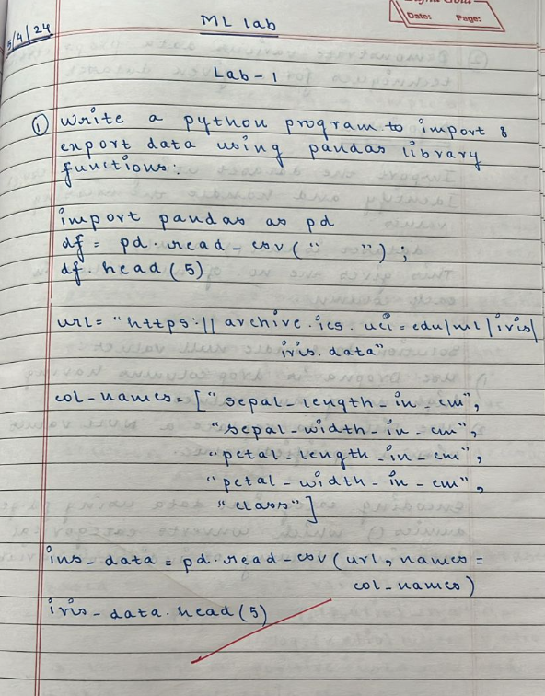

import pandas as pd df=pd.read_csv("austinHousingData.csv") print(df.head())

df.to_csv("exported_dataset.csv")

Output:

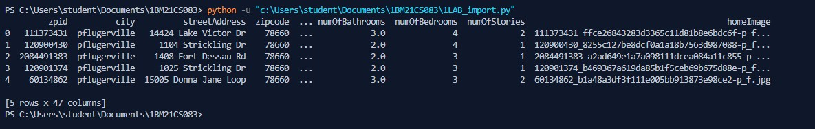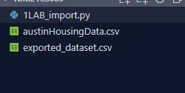

import pandas as pd url = "https://archive.ics.uci.edu/ml/machine-learning-databases/iris/iris.data"

col_names = ["sepal_length_in_cm",

"sepal_width_in_cm",

"petal_length_in_cm",

"petal_width_in_cm",

"class"]

iris_data = pd.read_csv(url, names=col_names)

print(iris_data.head())

iris_data.to_csv("cleaned_iris_data.csv")

Output:

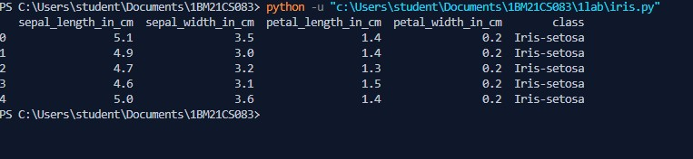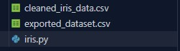

05.04.2024 1BM21CS124

2. Demonstrate various data pre-processing techniques for a given dataset

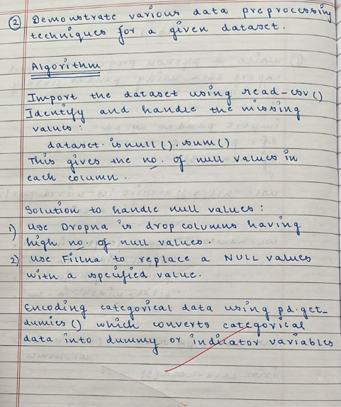

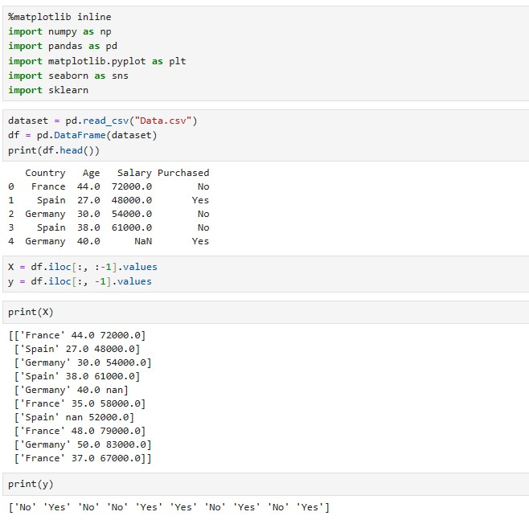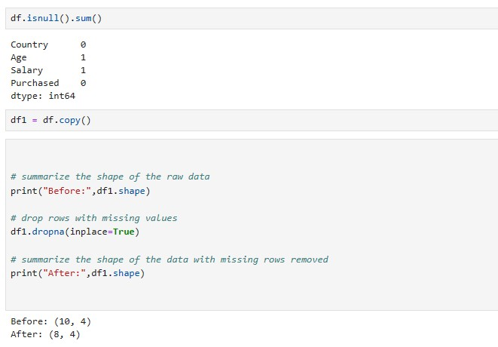

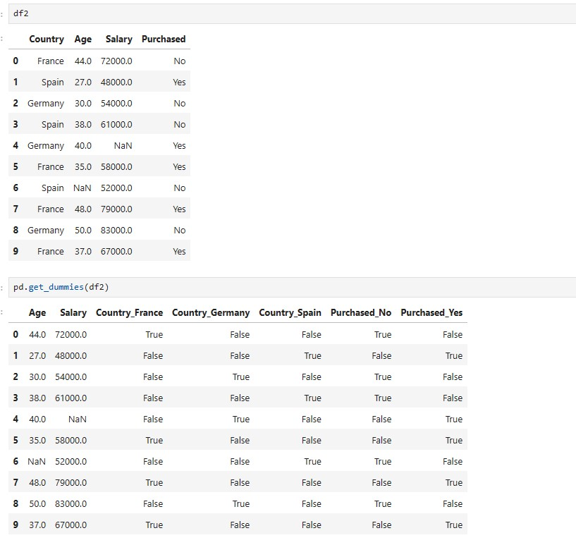

12/04/2024

Decision Tree Algorithm:

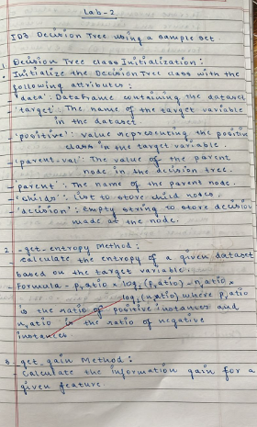

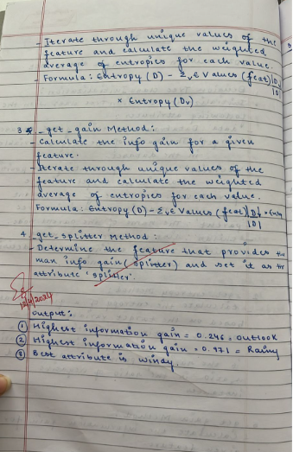

Code and output:

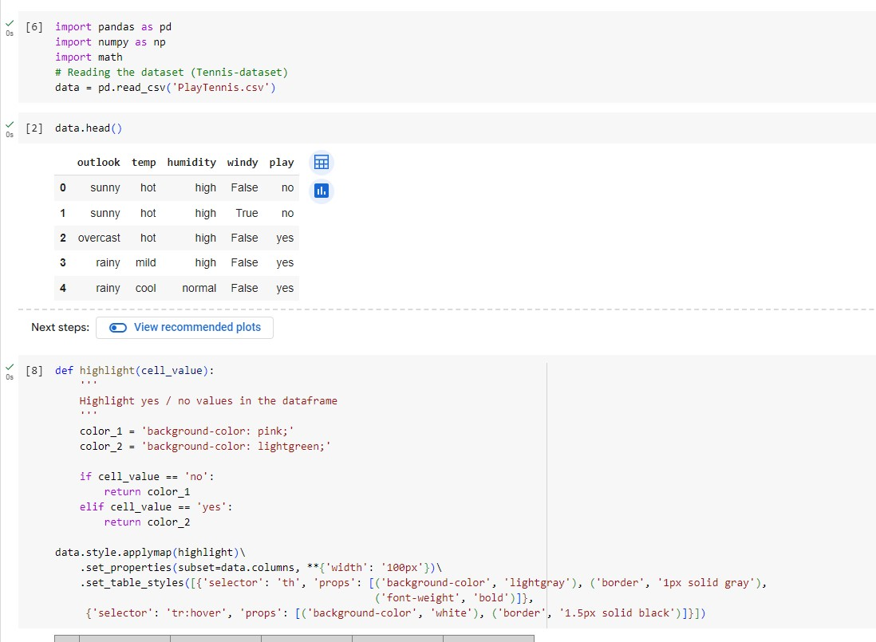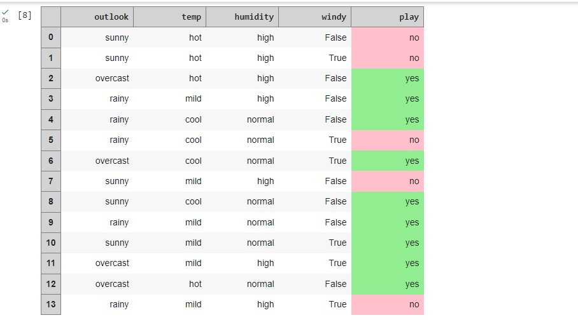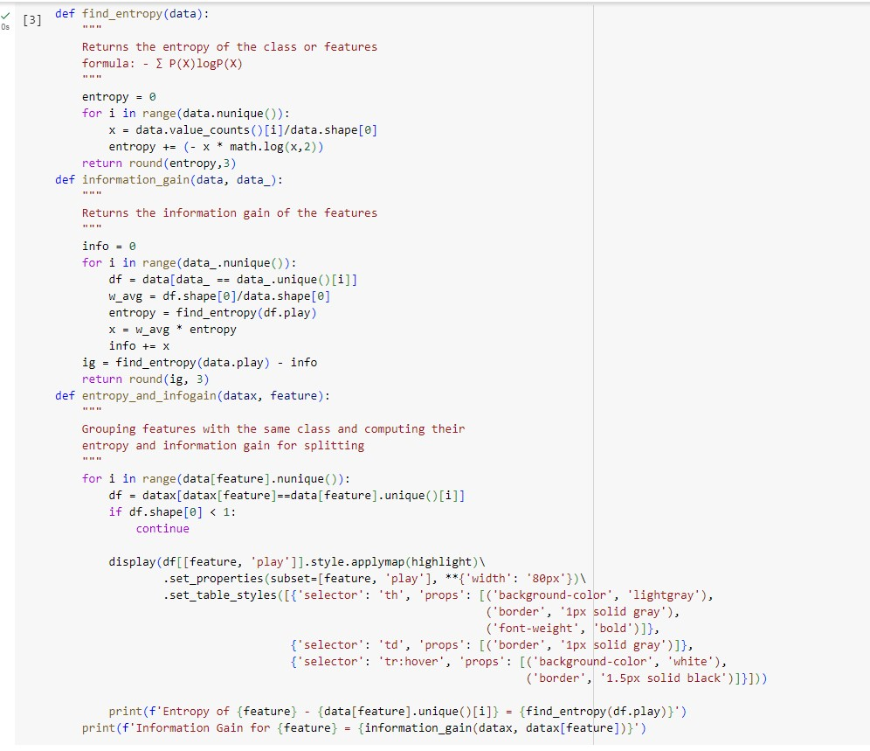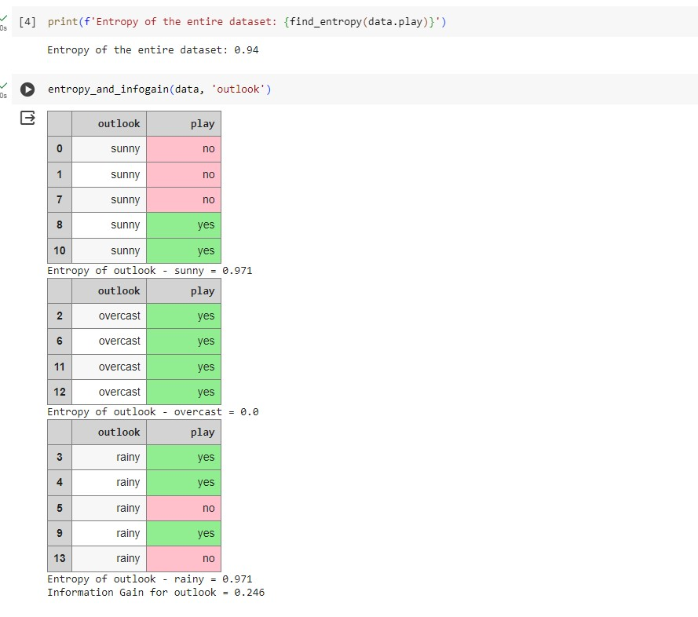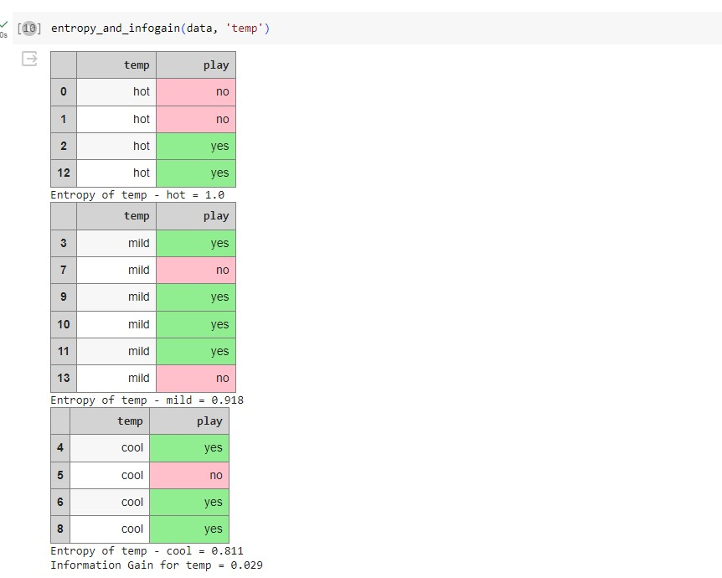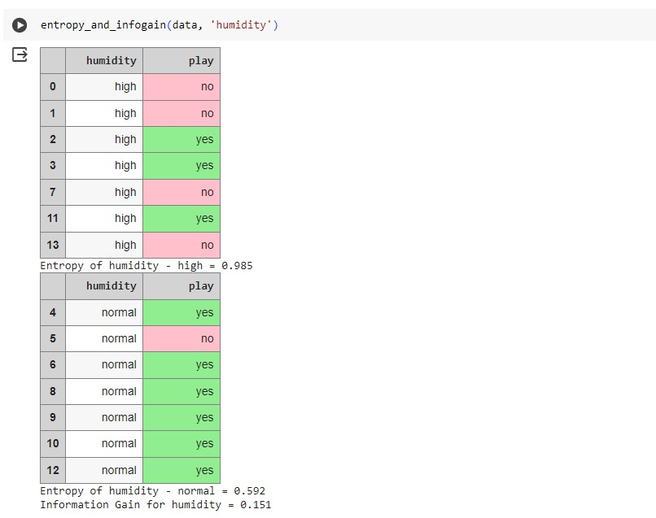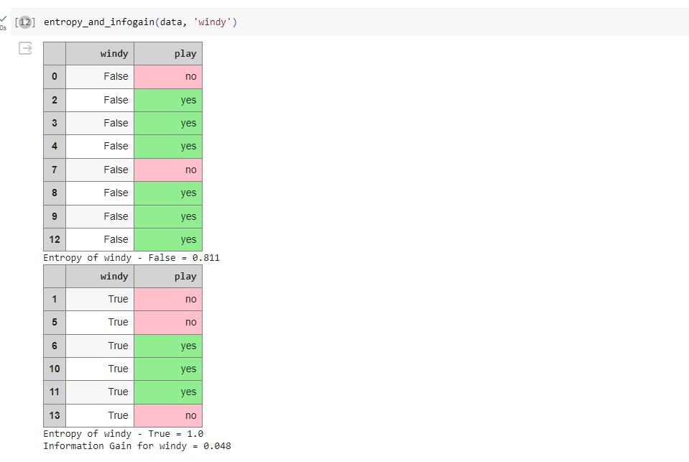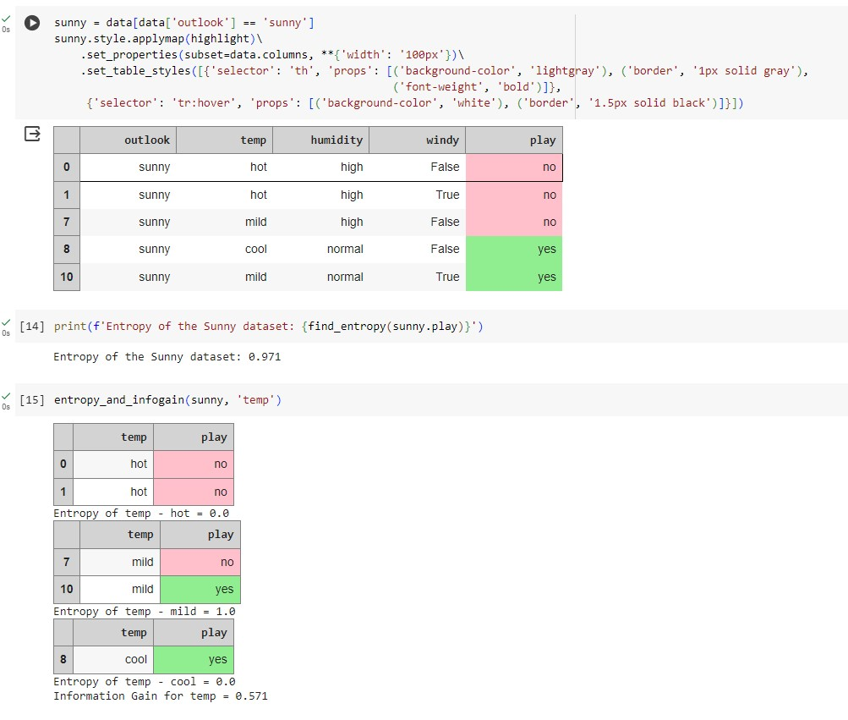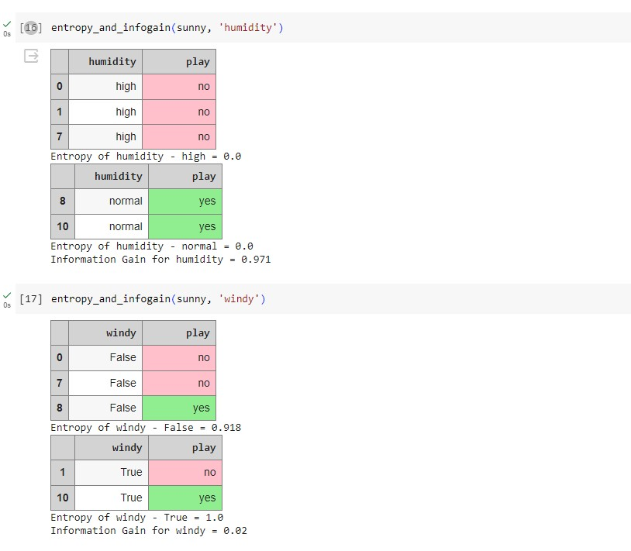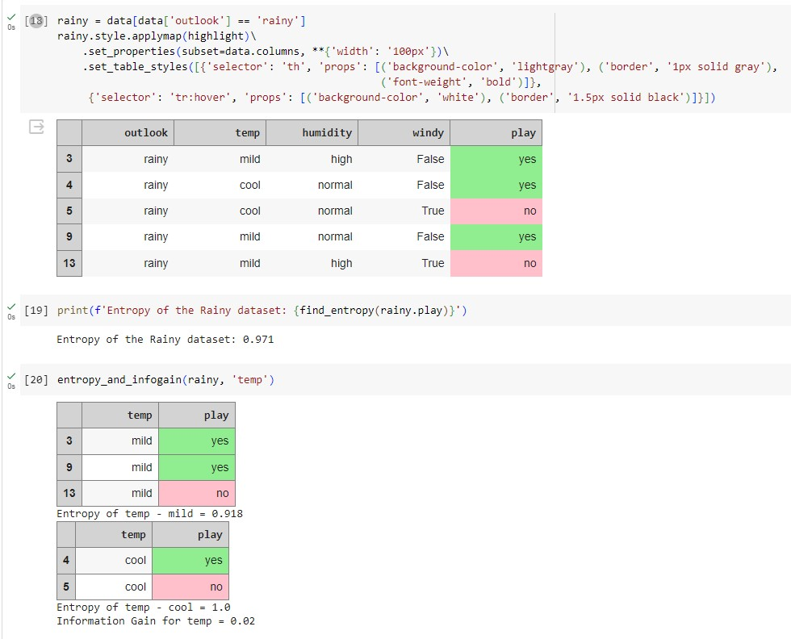

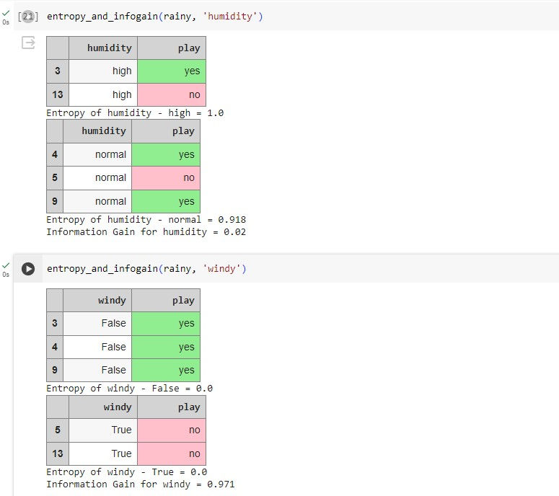

03/05/2024

Build KNN Classification model for a given dataset.:

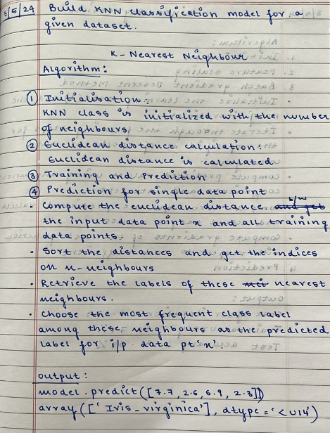

Code and output:

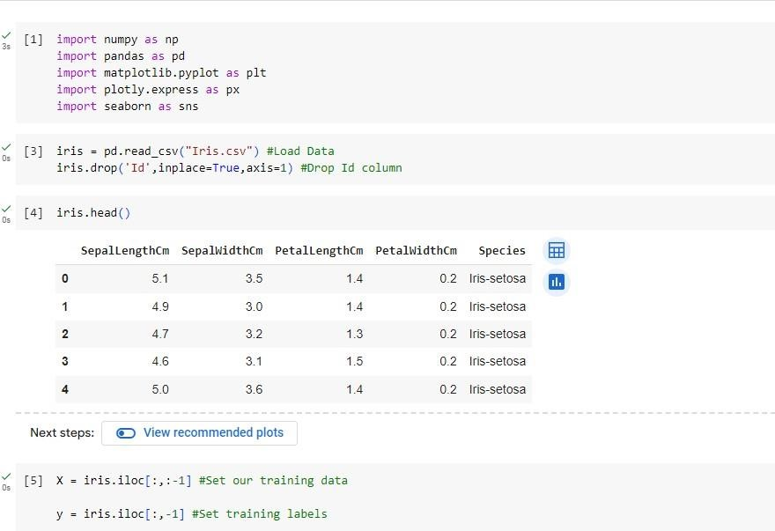

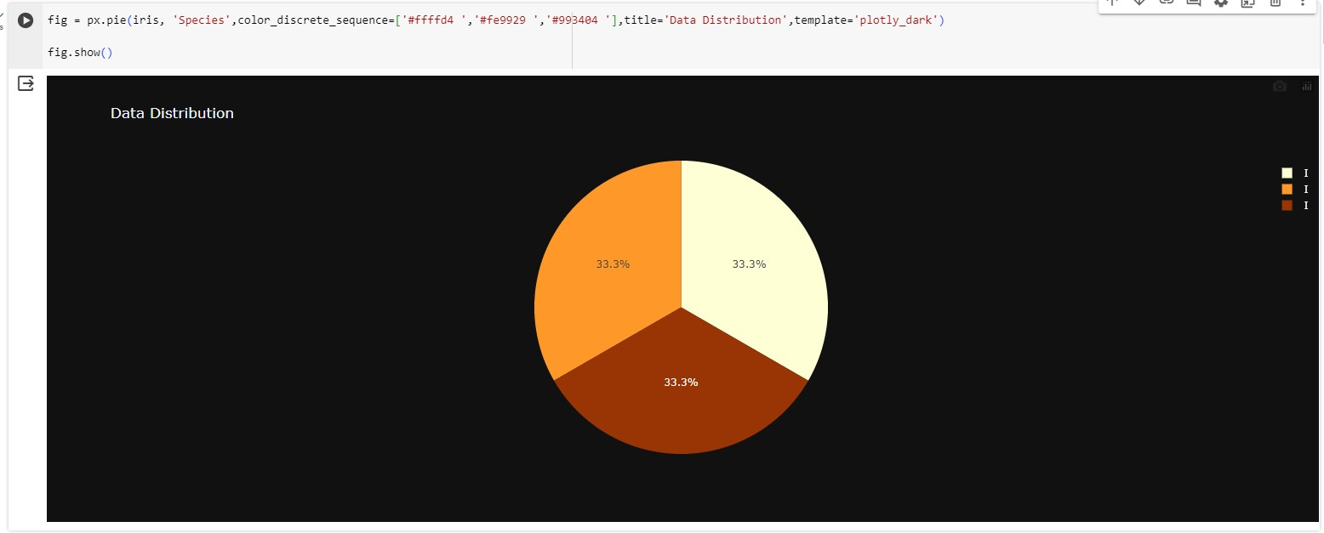

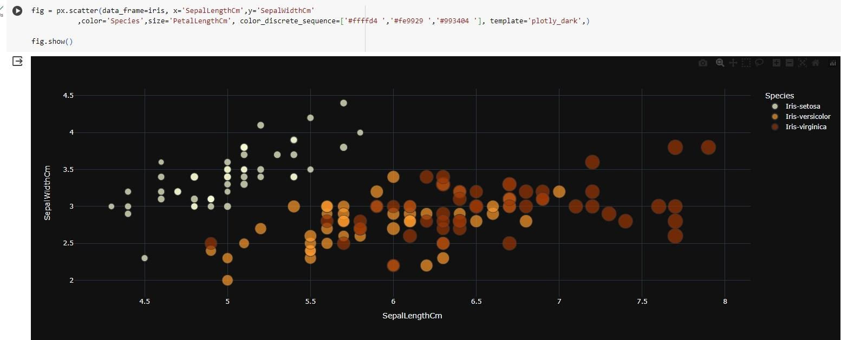

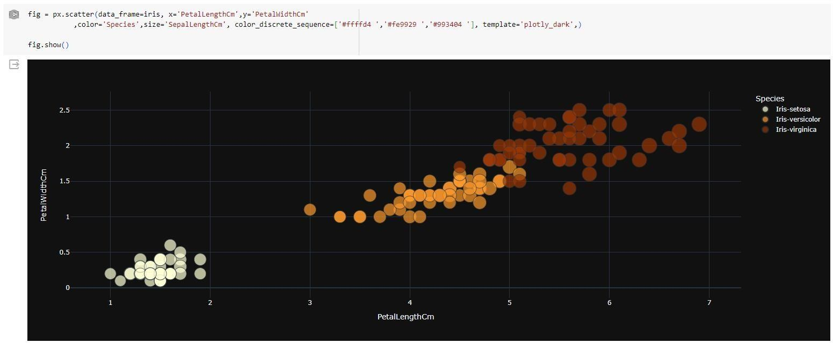

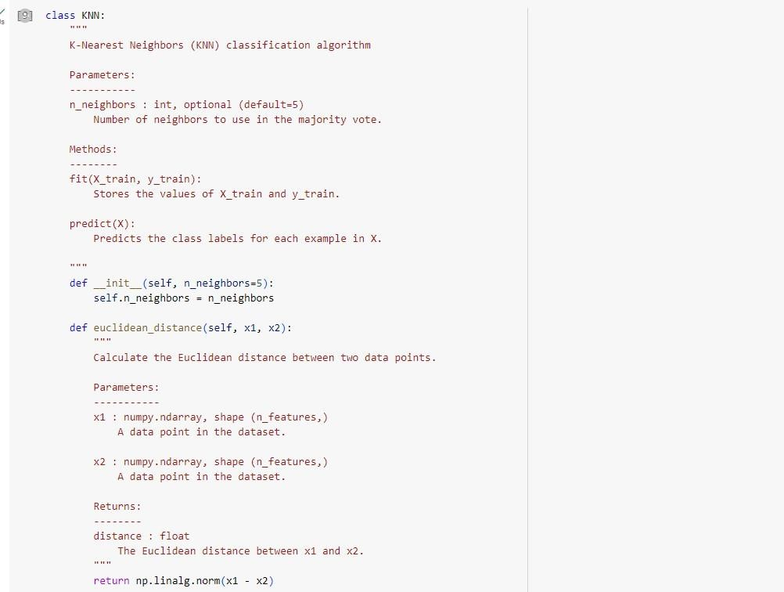

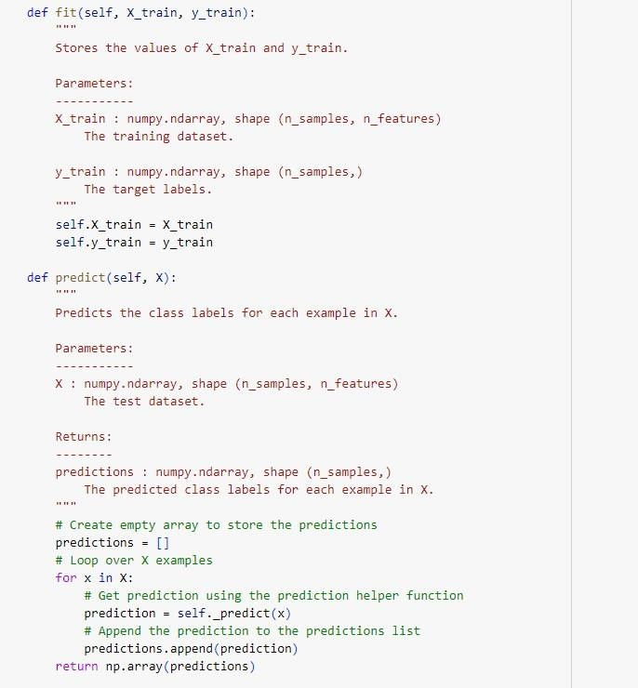

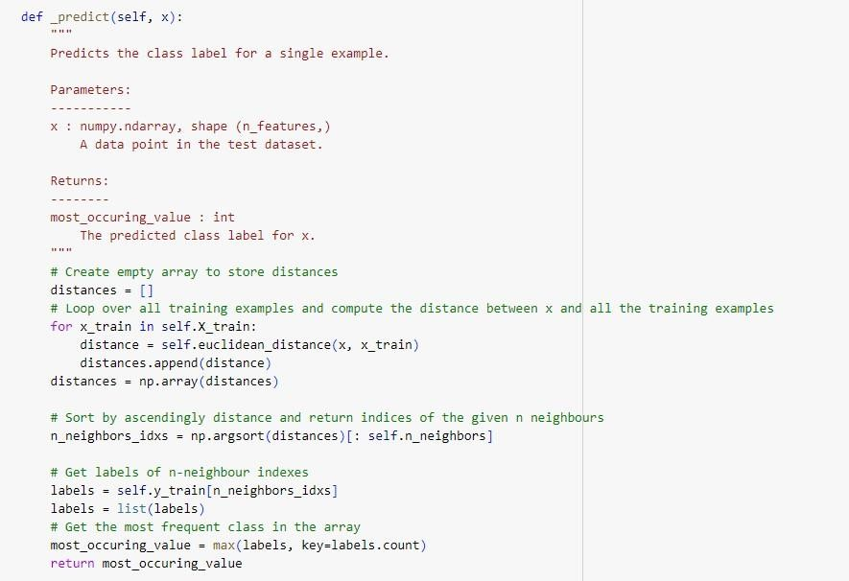

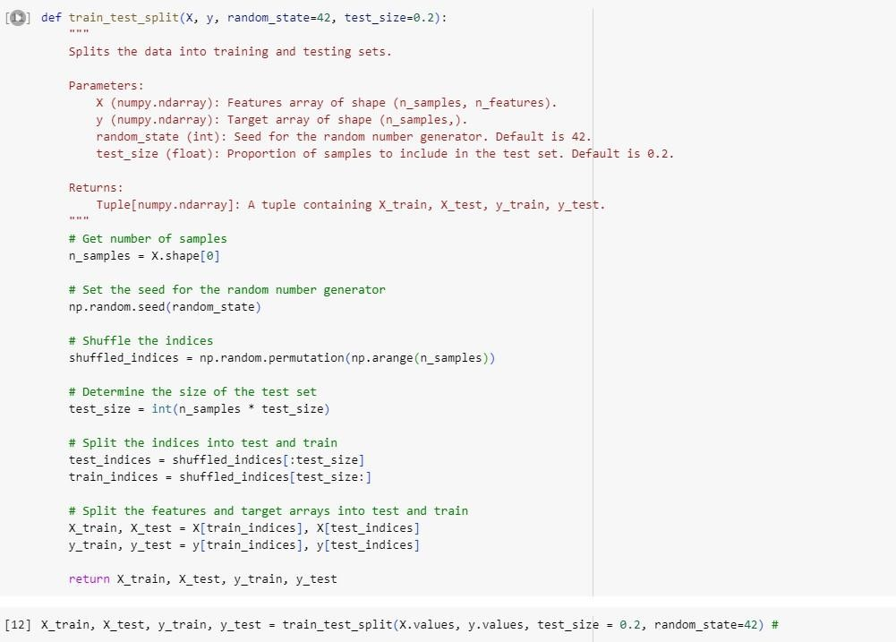

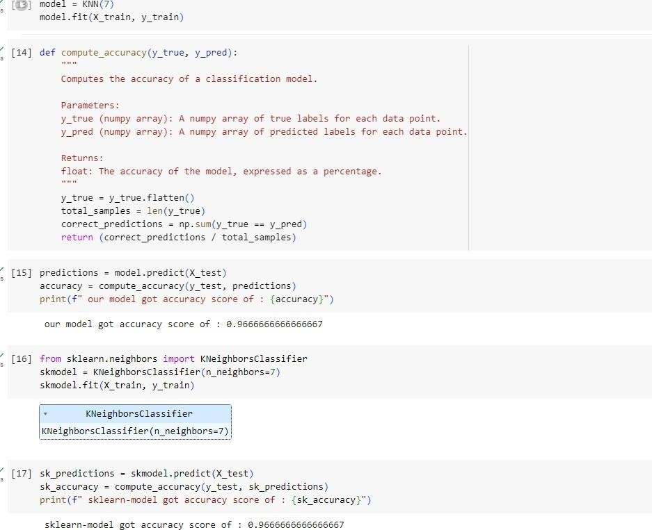

03/05/2024

# Linear Regression

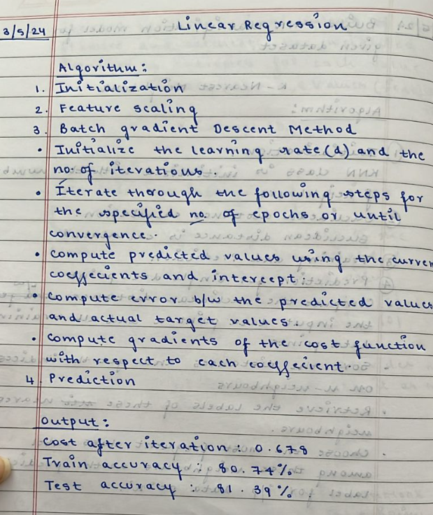

Code and output:

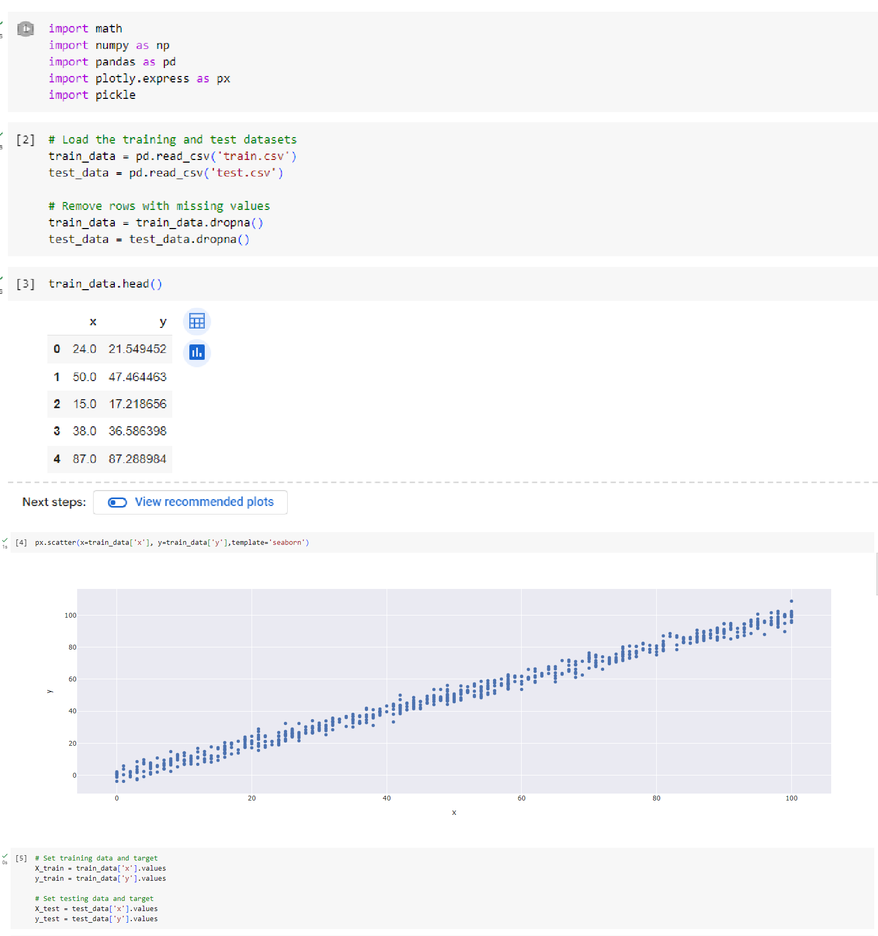

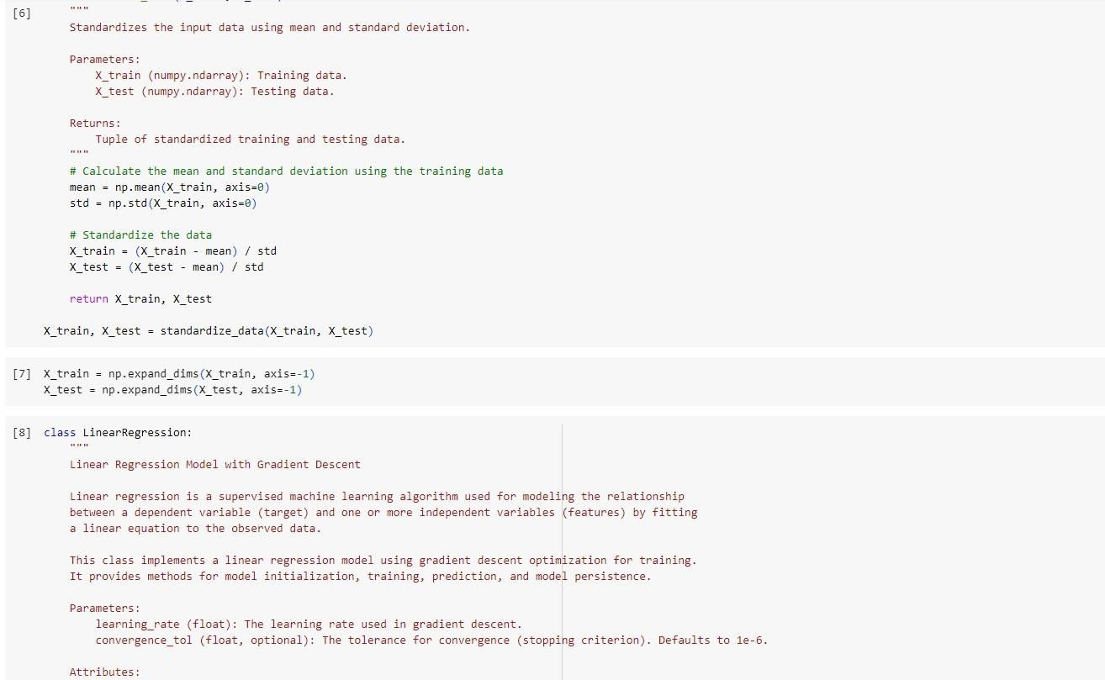

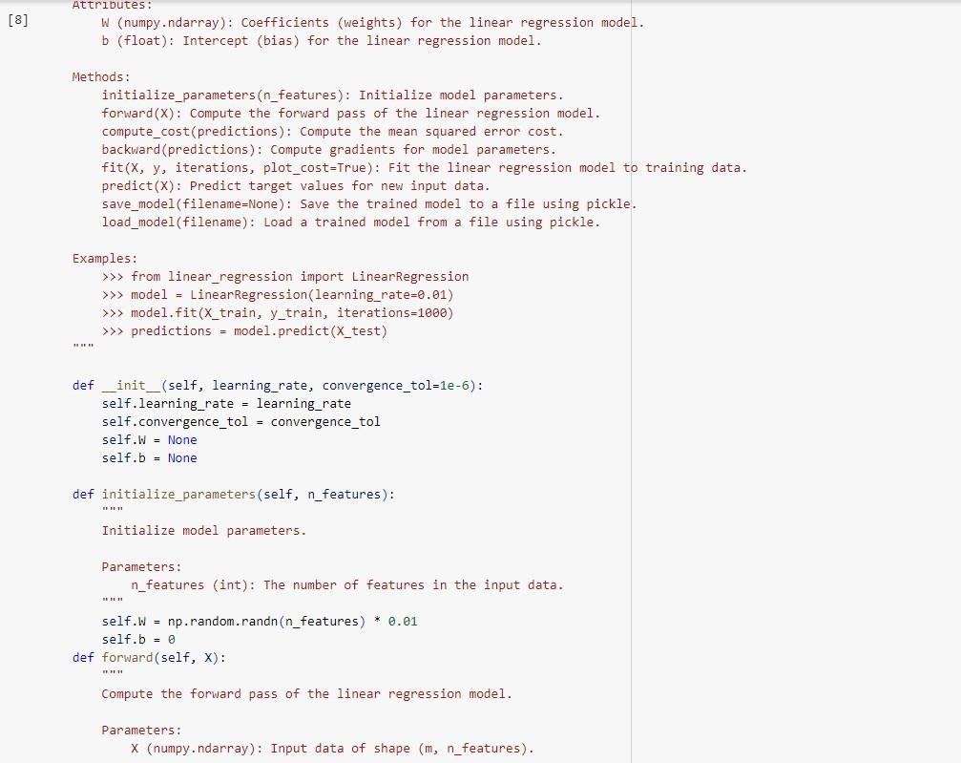

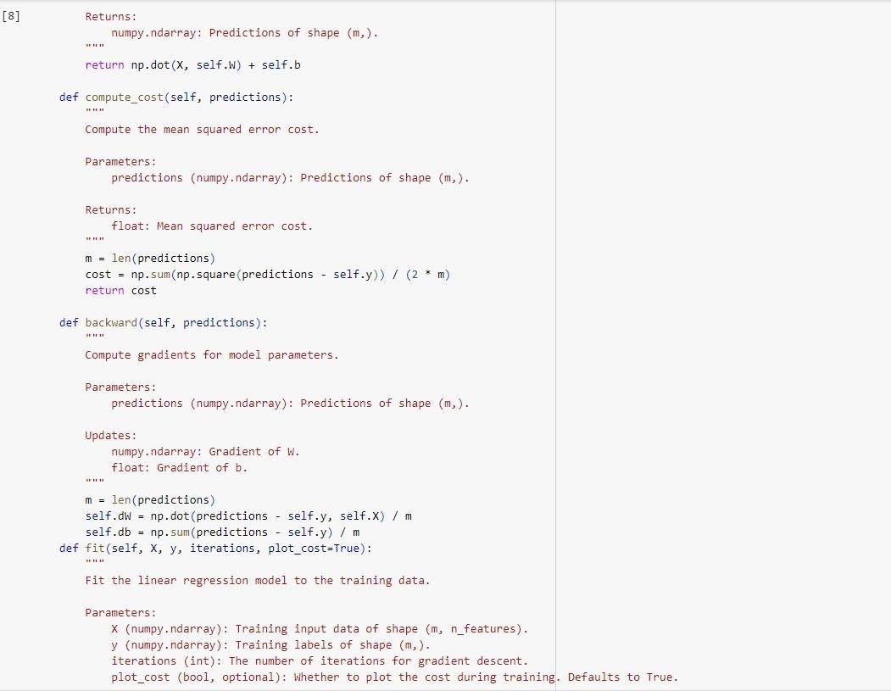

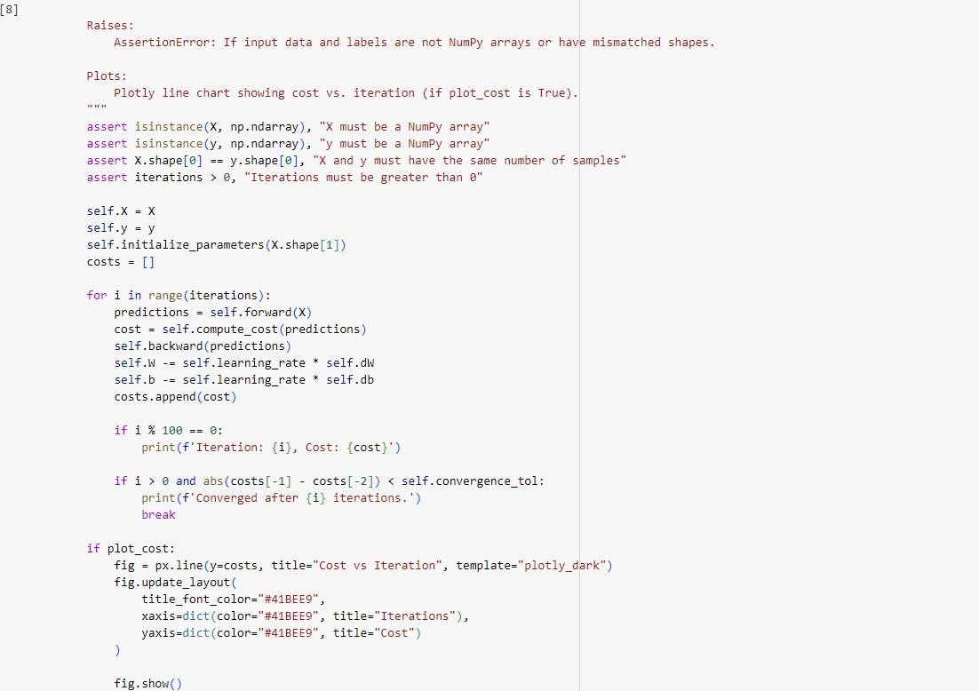

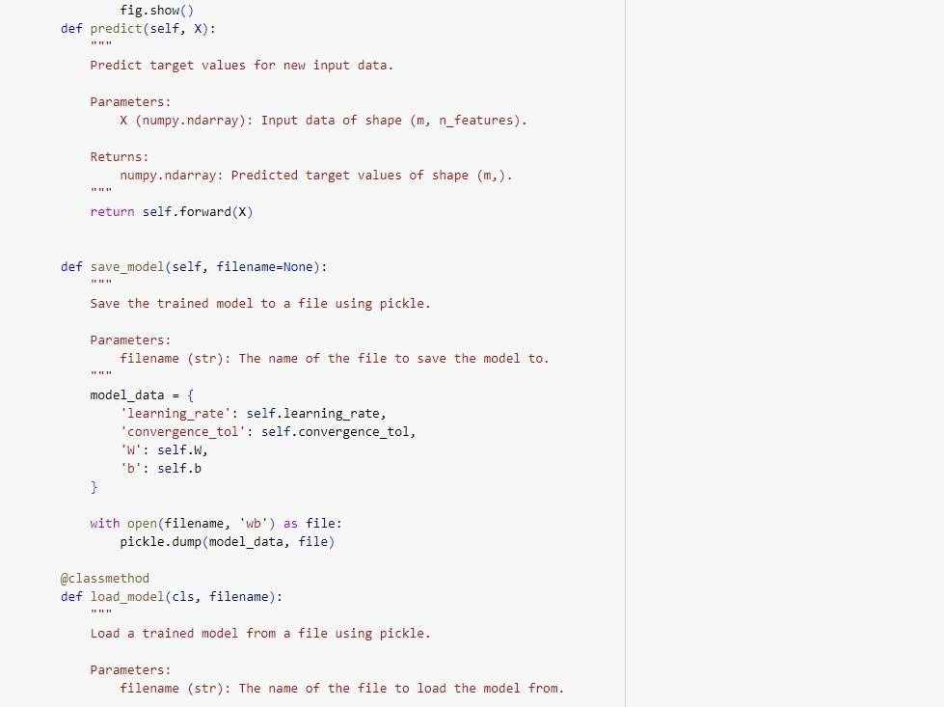

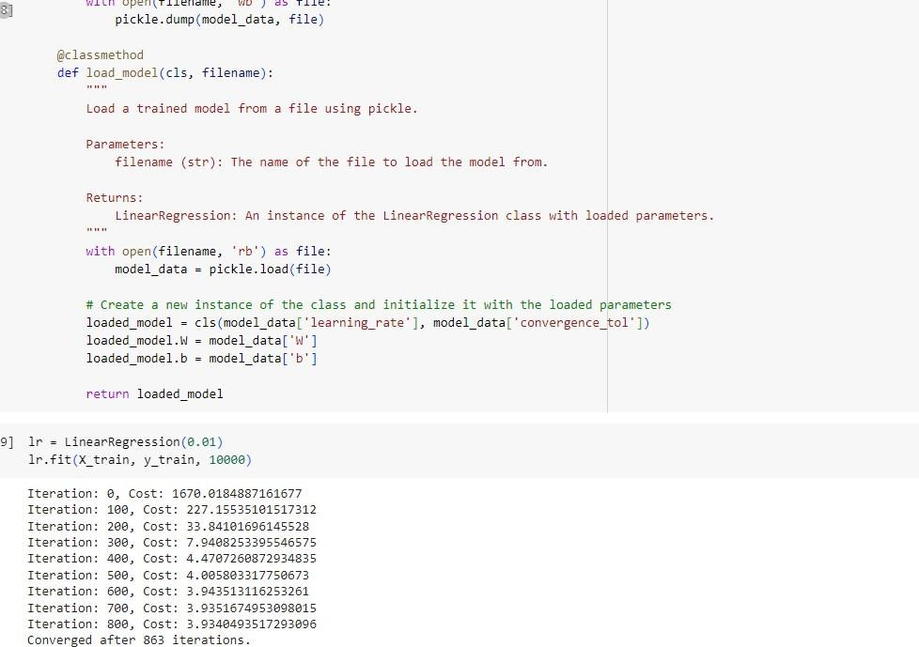

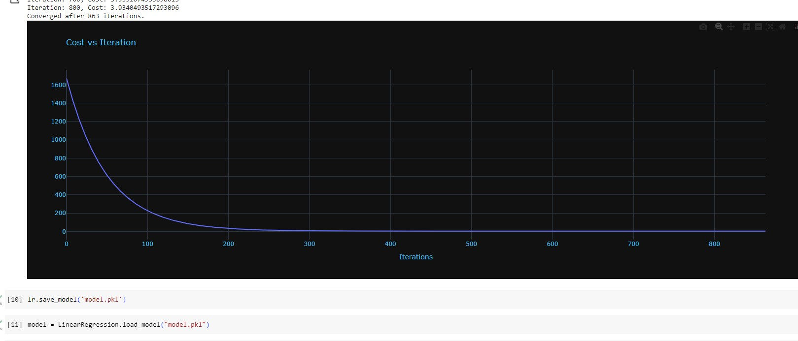

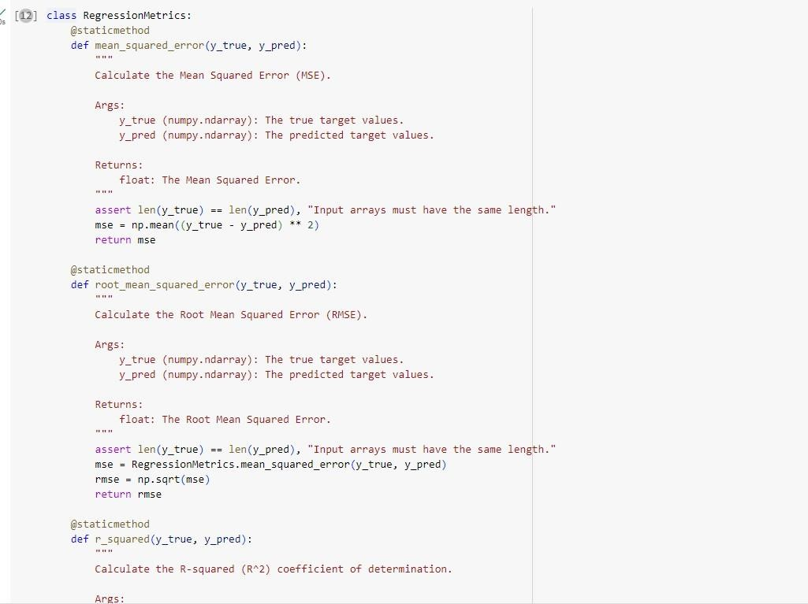

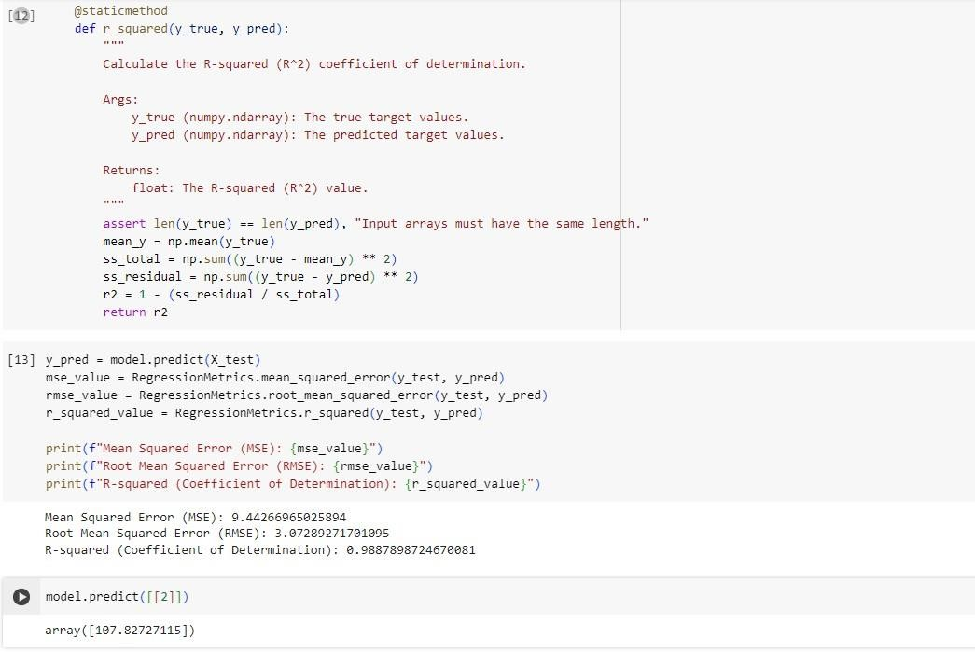

03/05/2024

# Logistic Regression

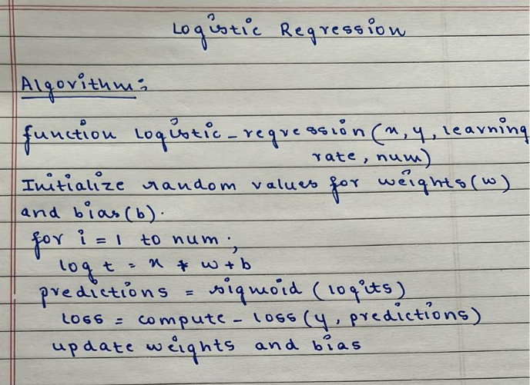

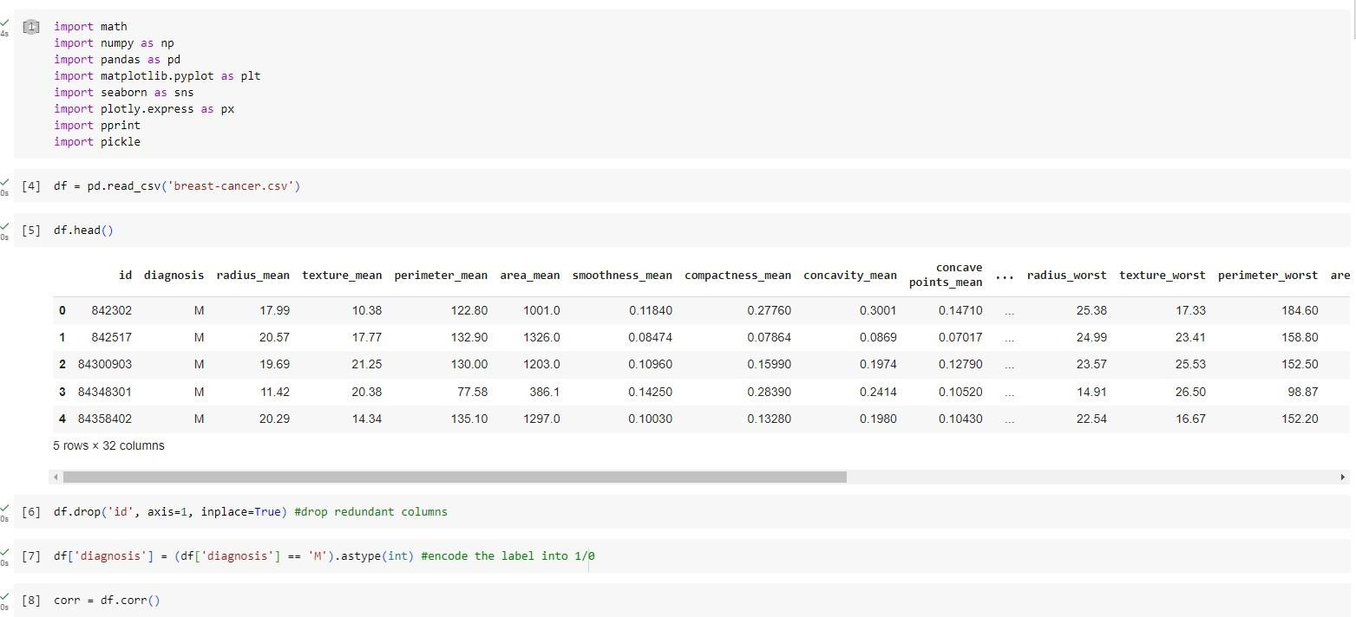

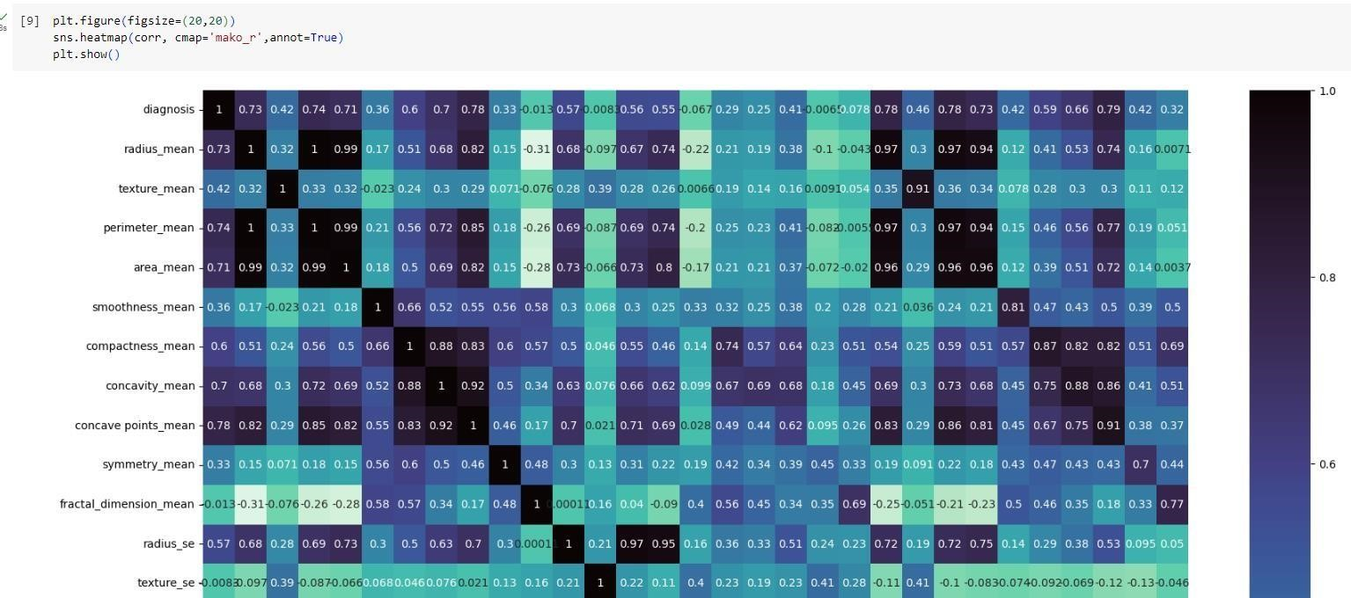

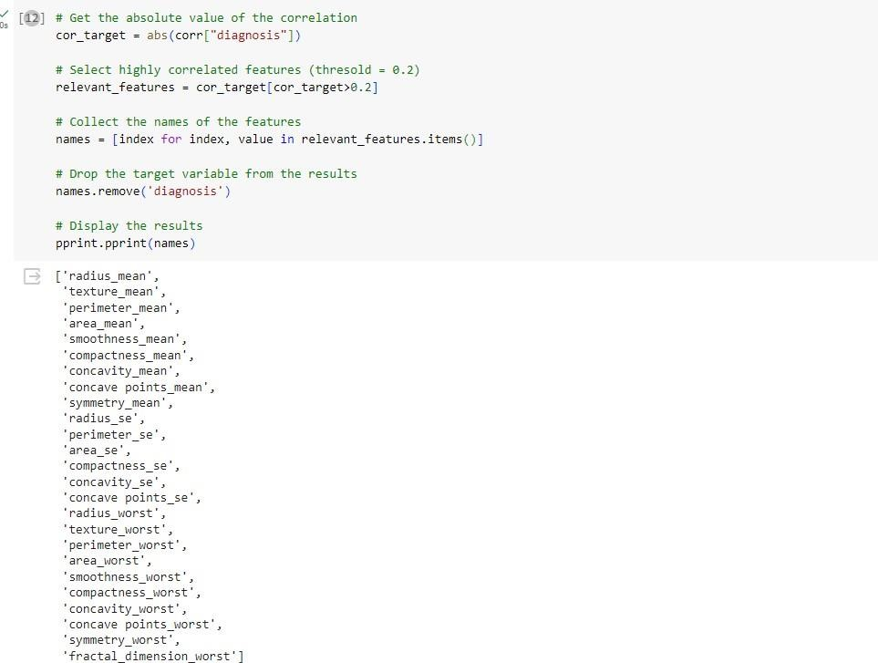

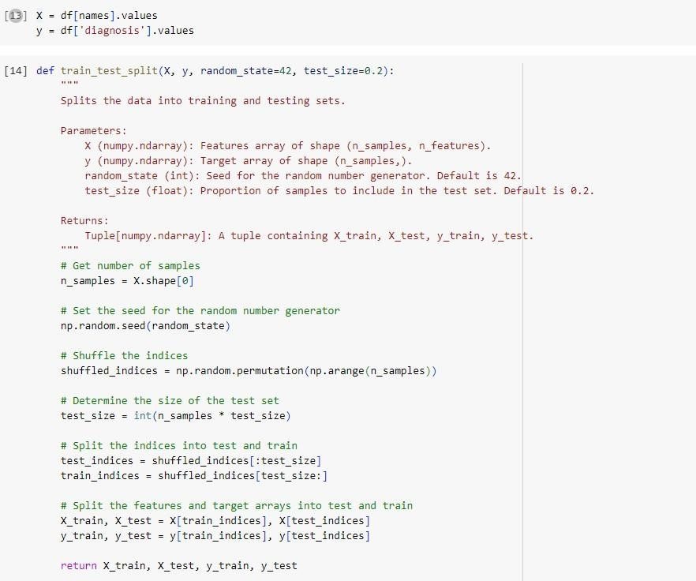

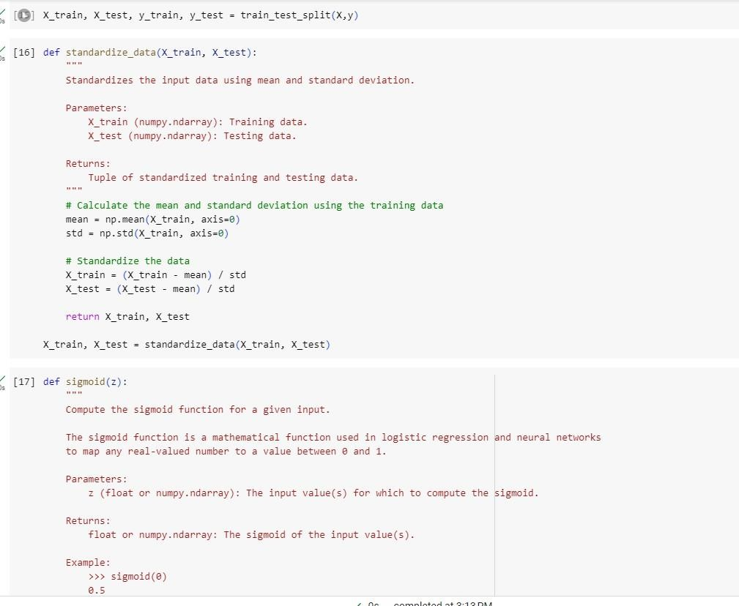

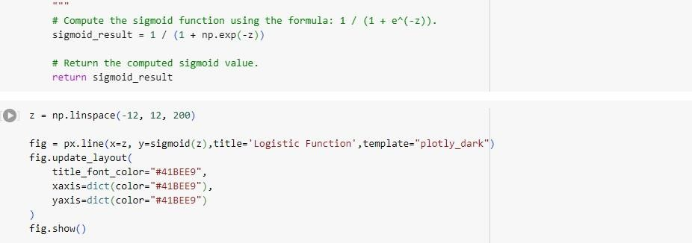

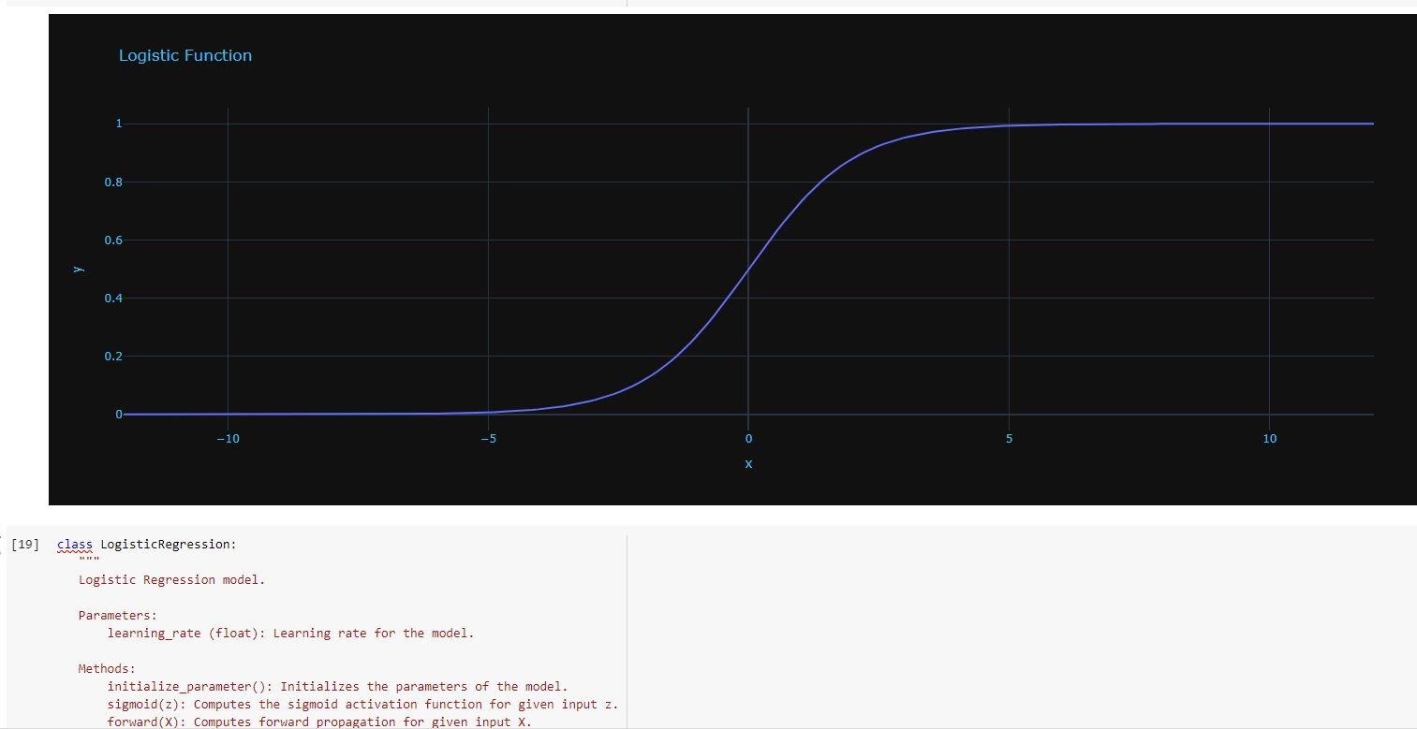

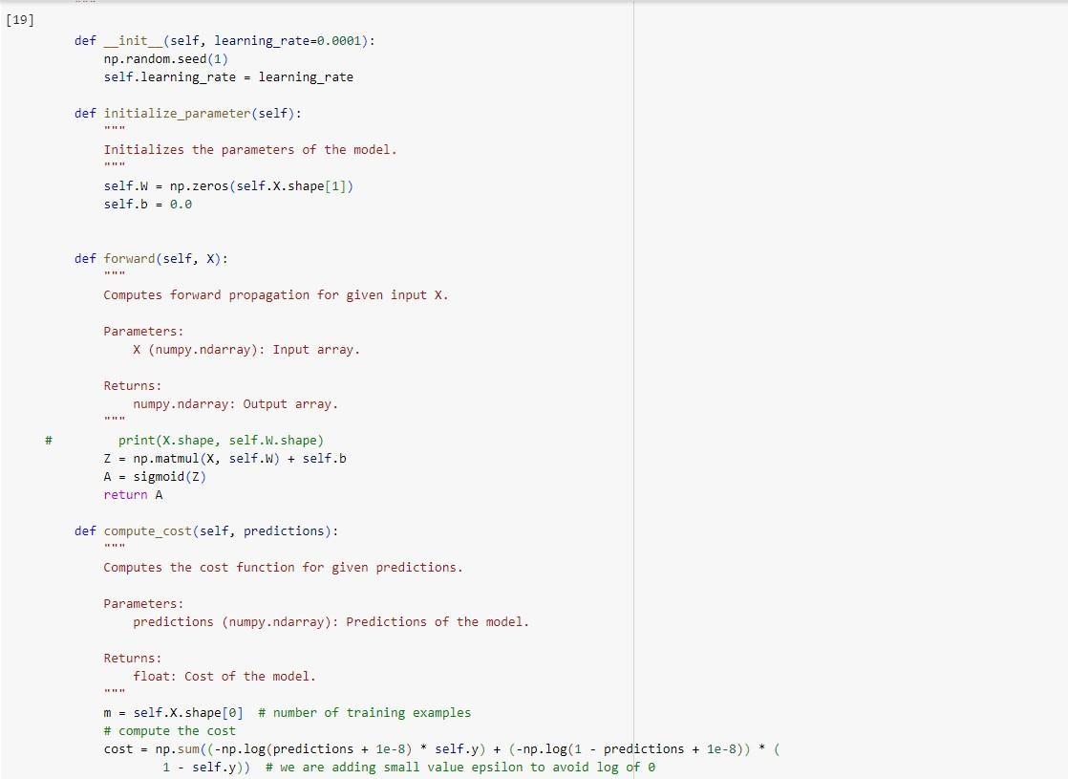

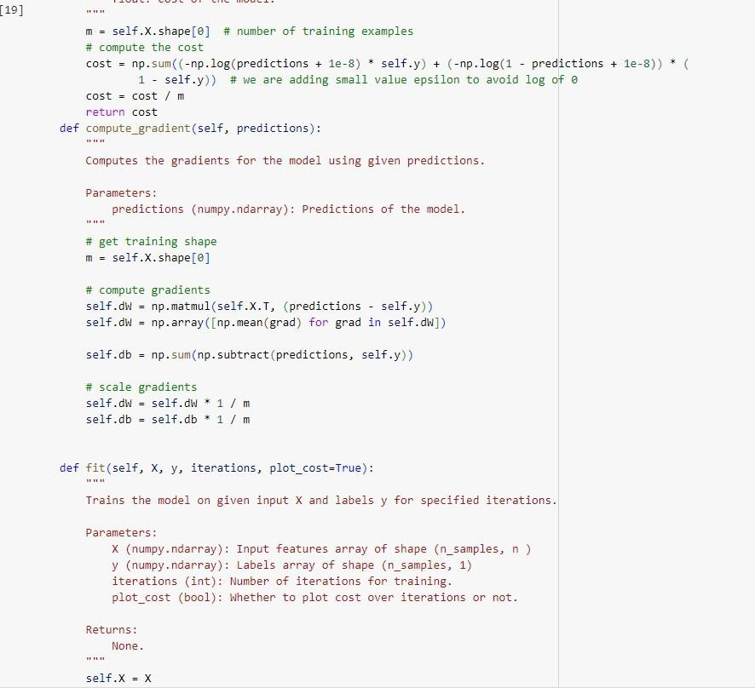

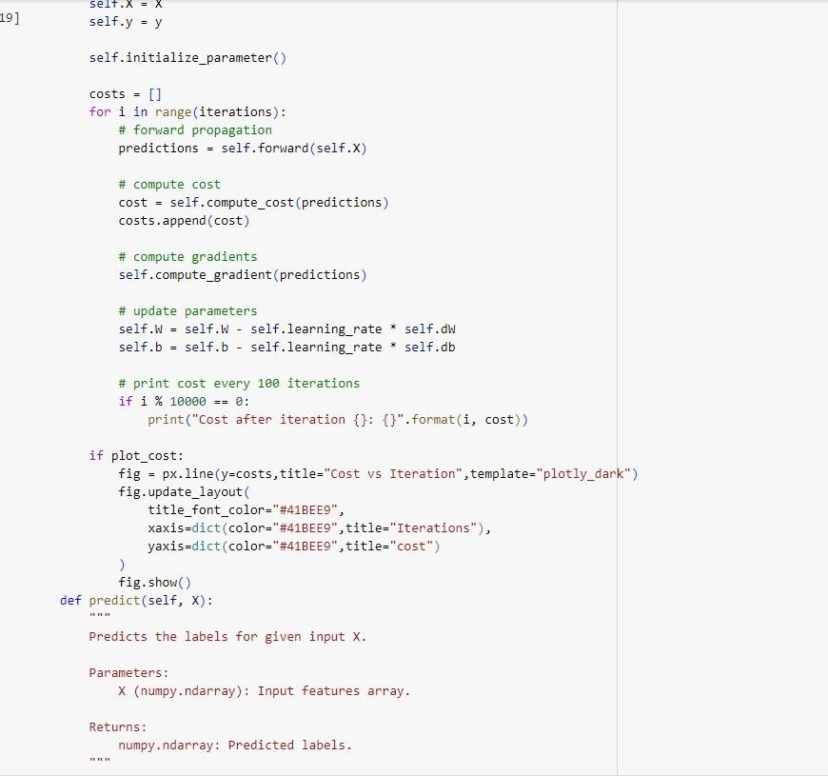

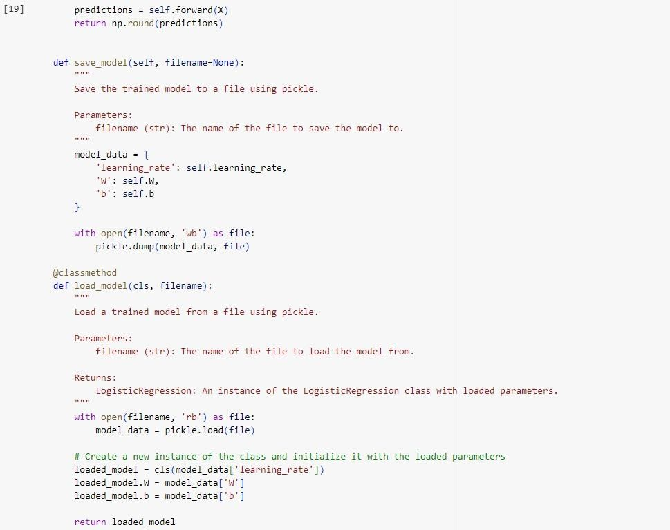

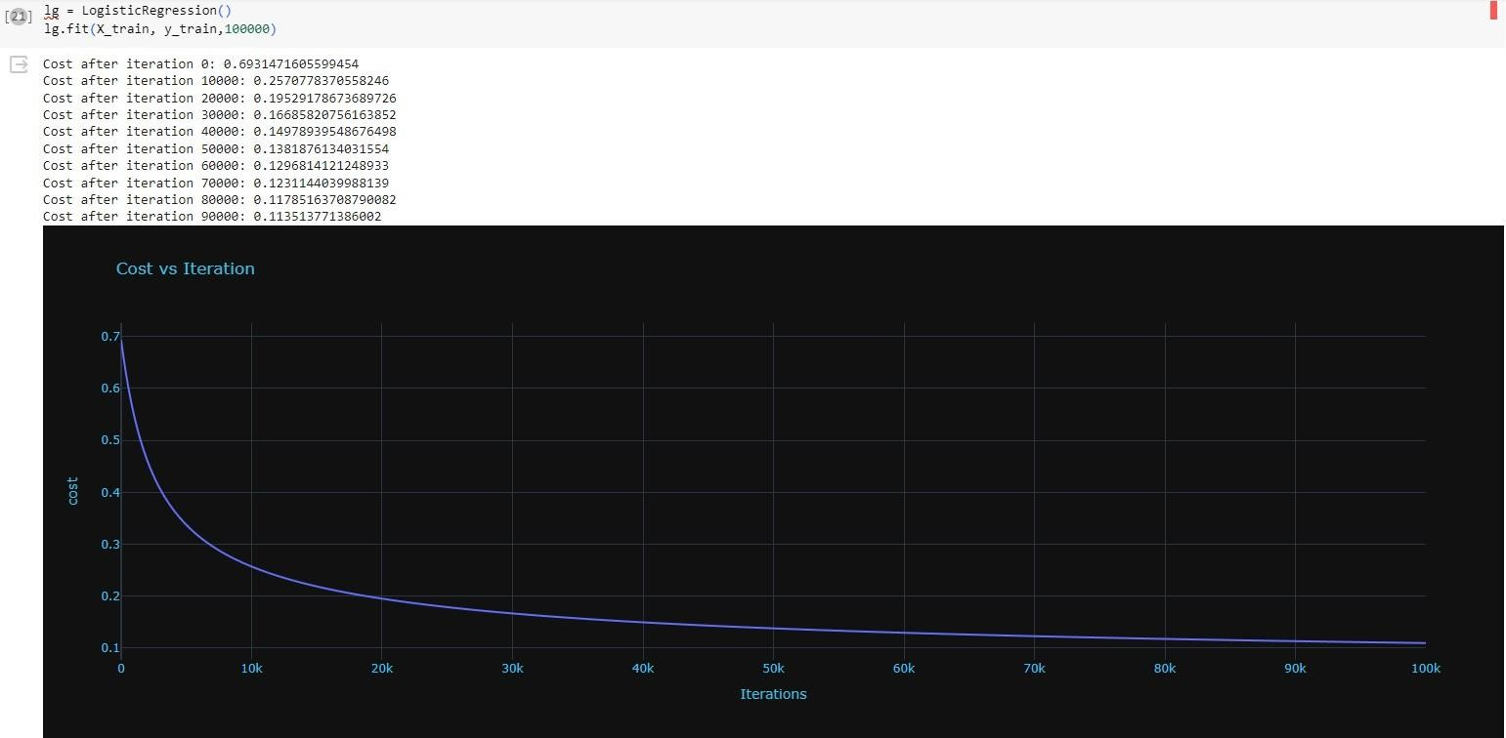

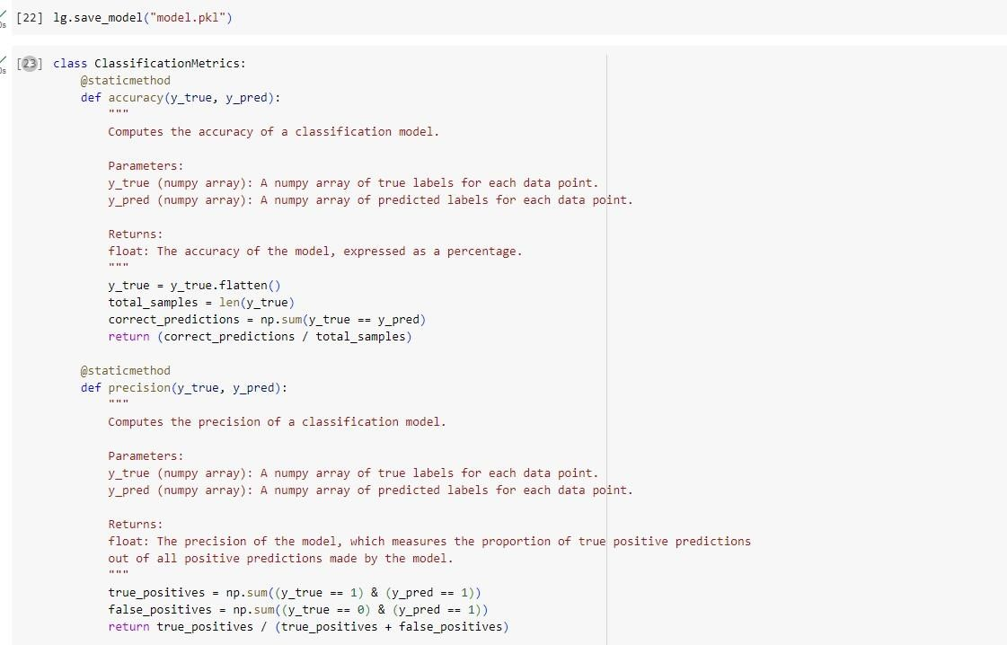

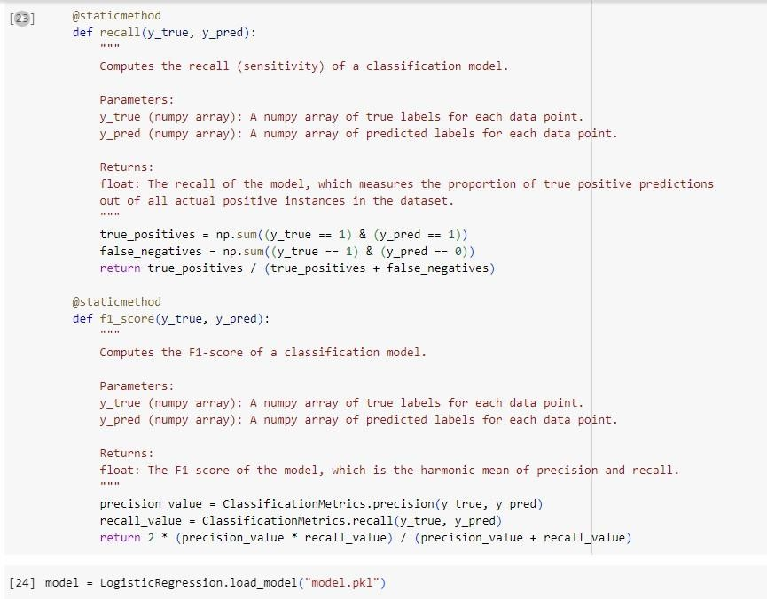

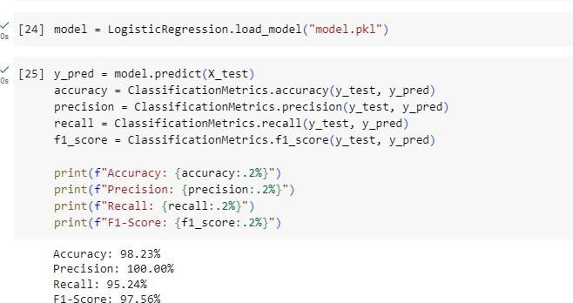

24/05/2024

Build Support vector machine model for a given dataset

Algorithm:

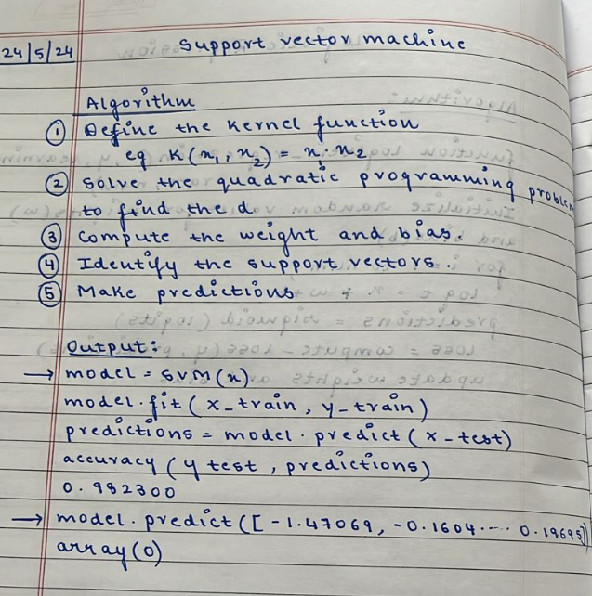

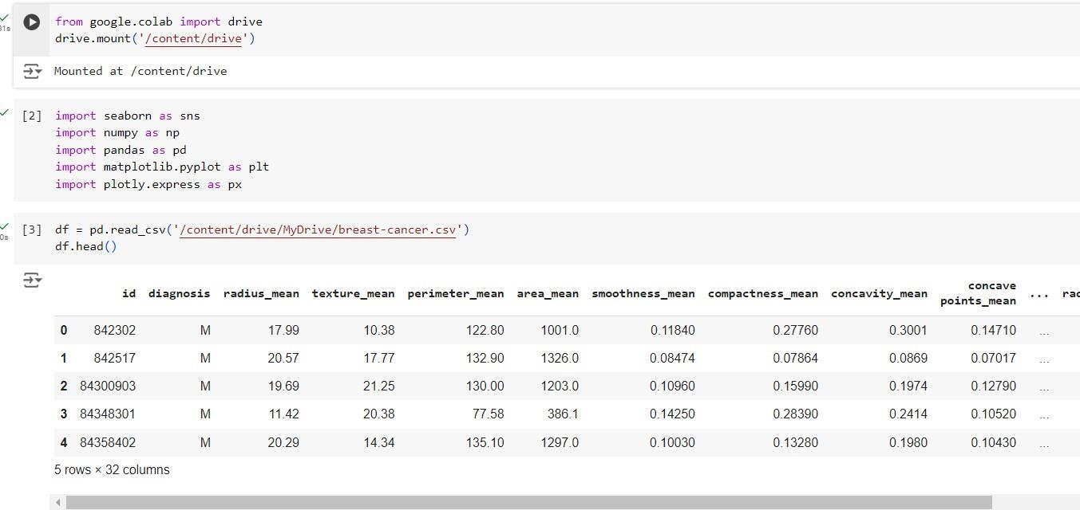

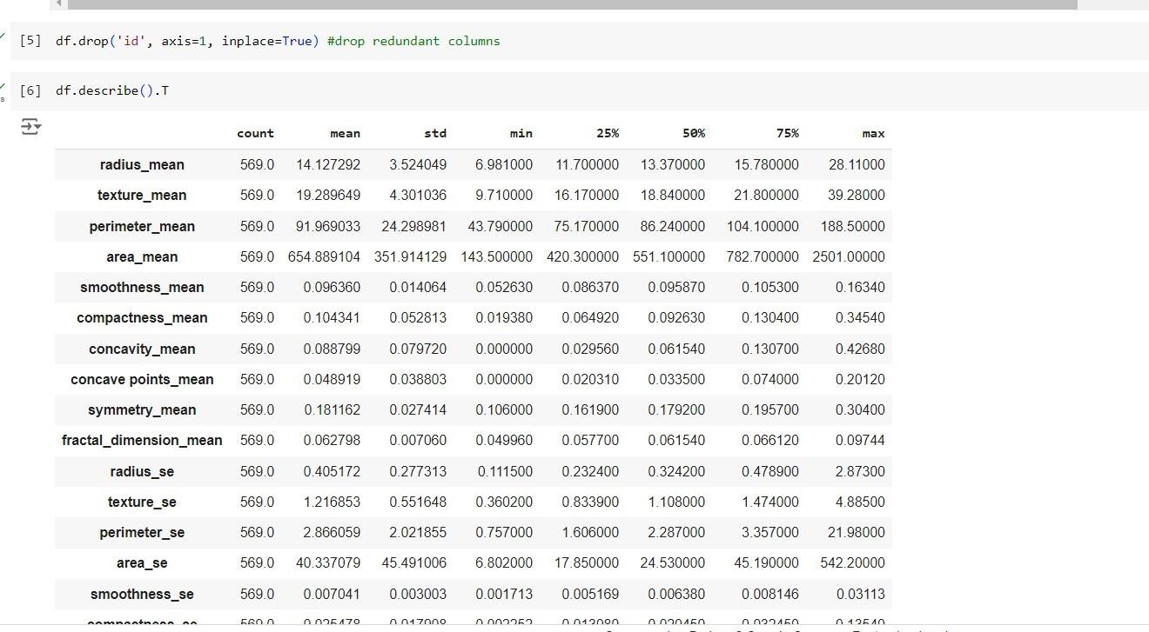

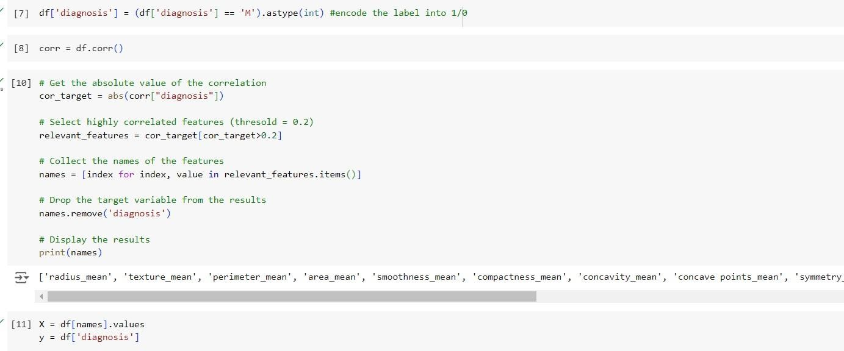

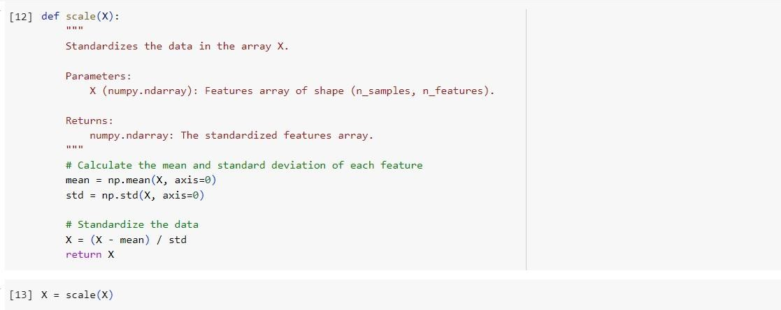

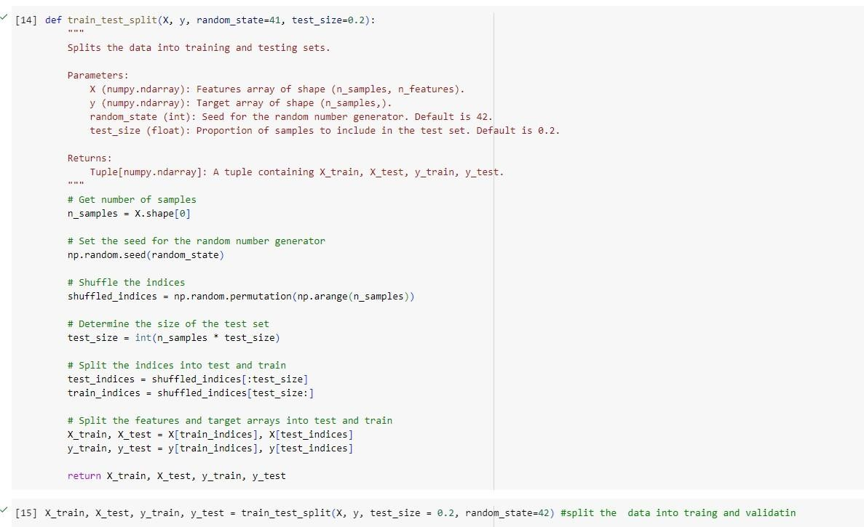

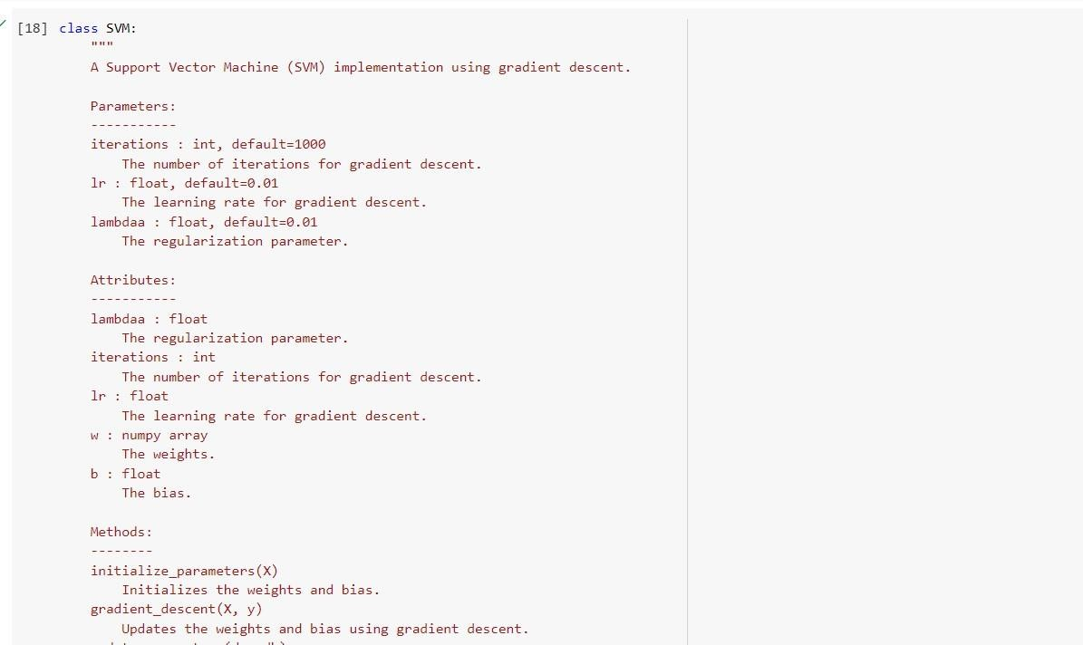

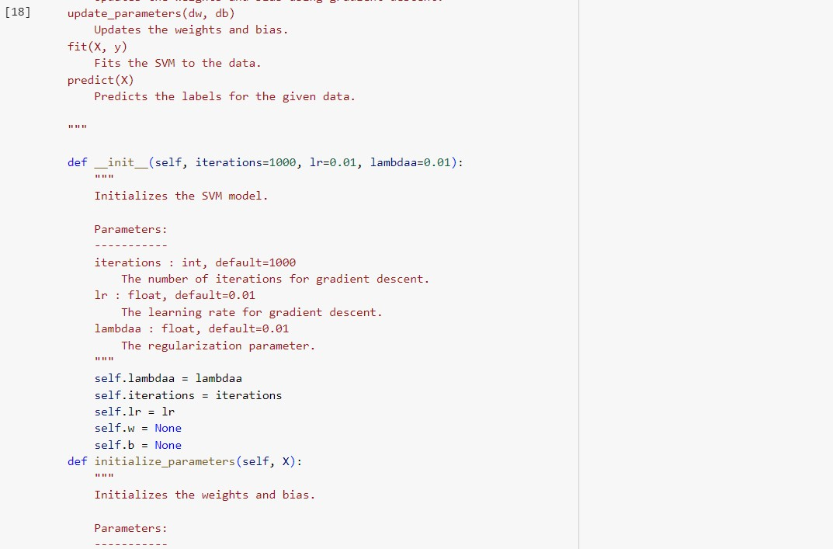

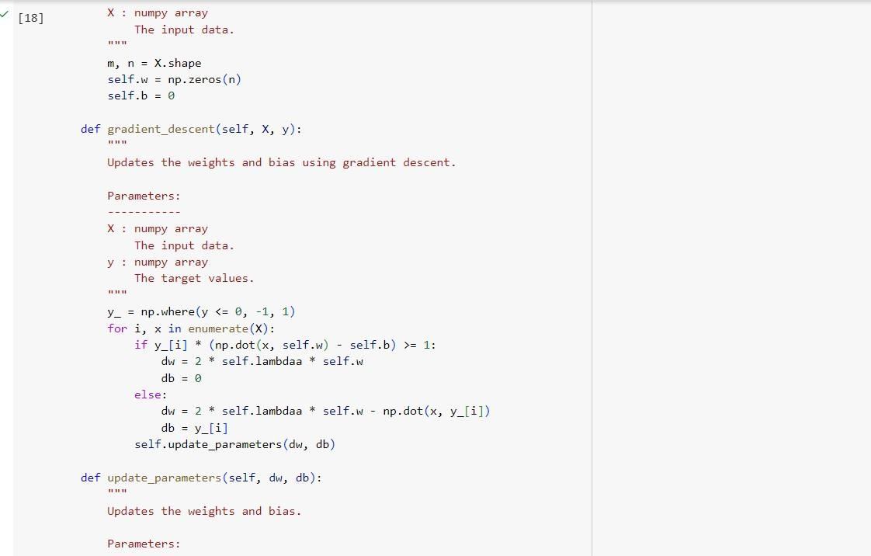

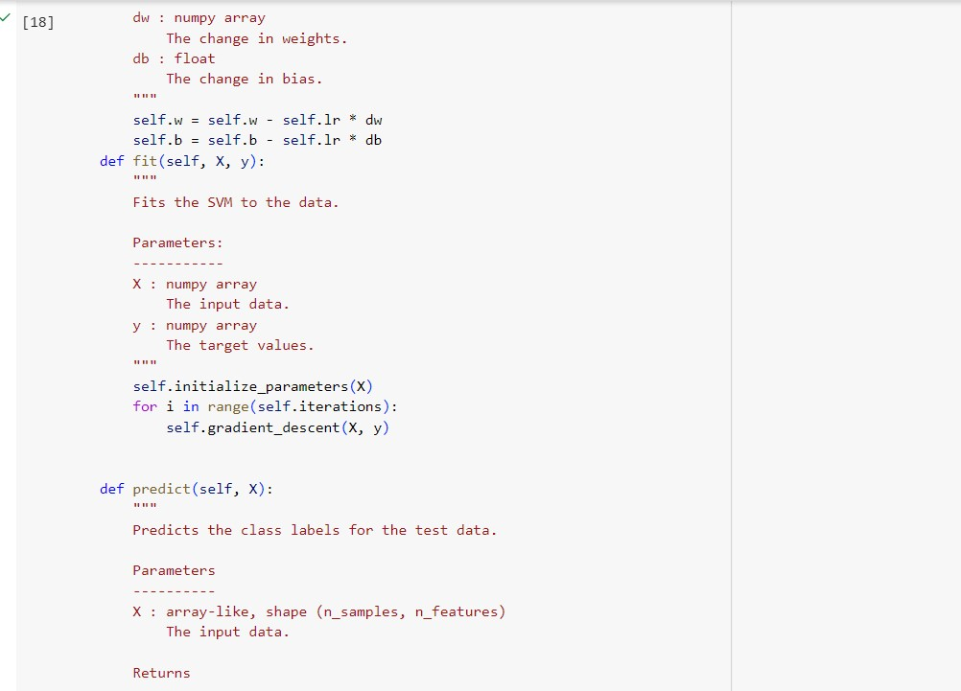

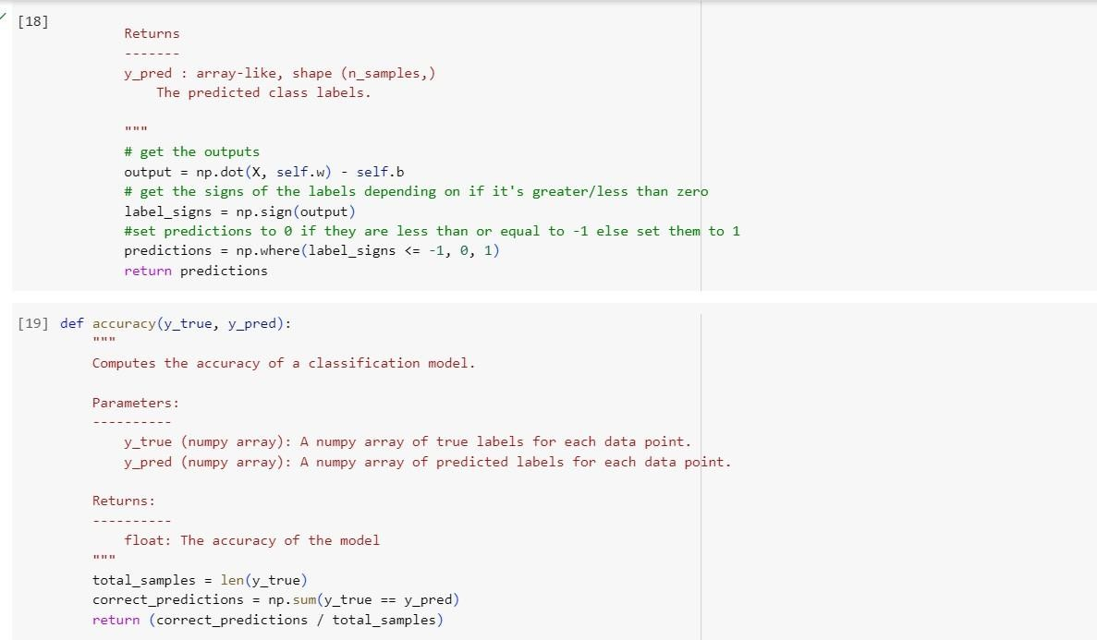

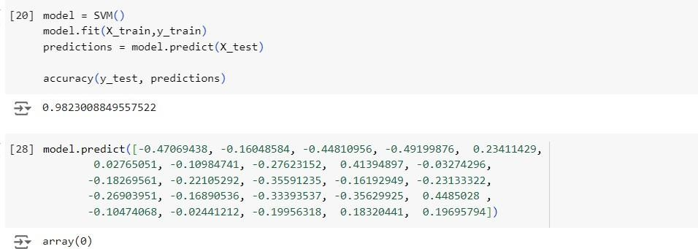

24/05/2024

Build k-Means algorithm to cluster a set of data stored in a .CSV file.

Algorithm:

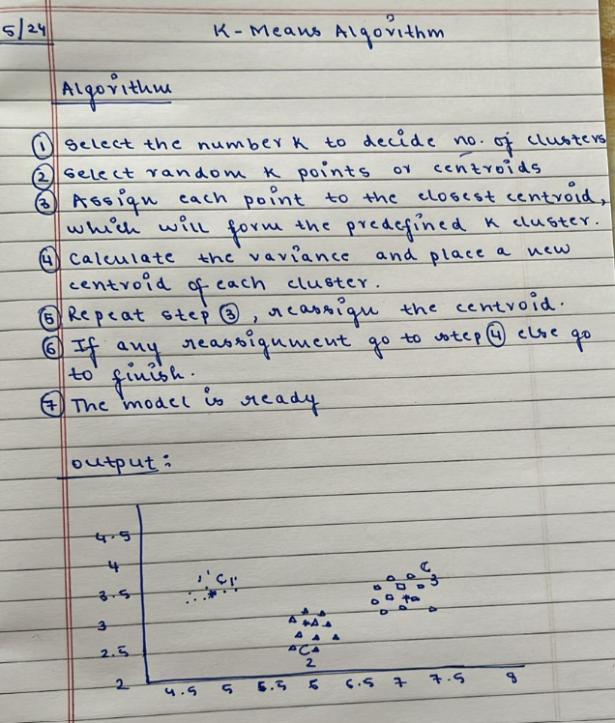

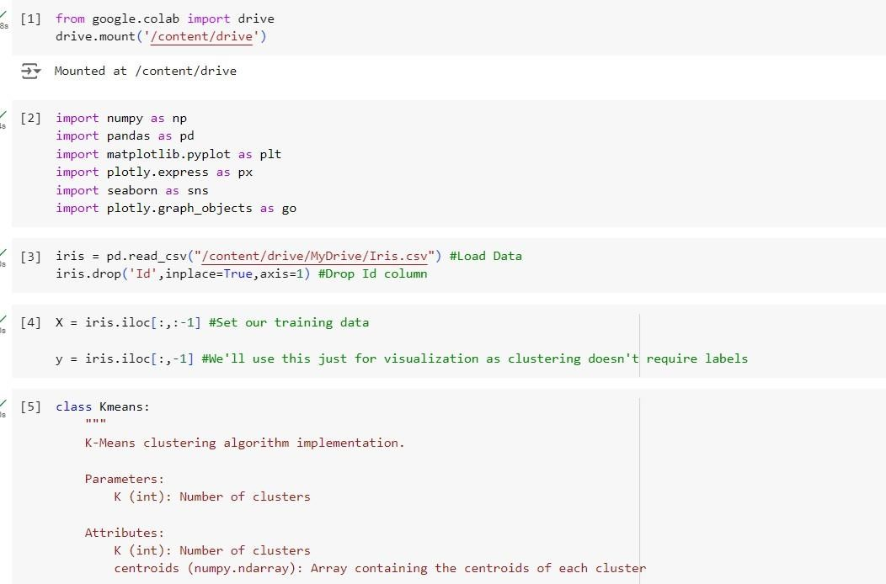

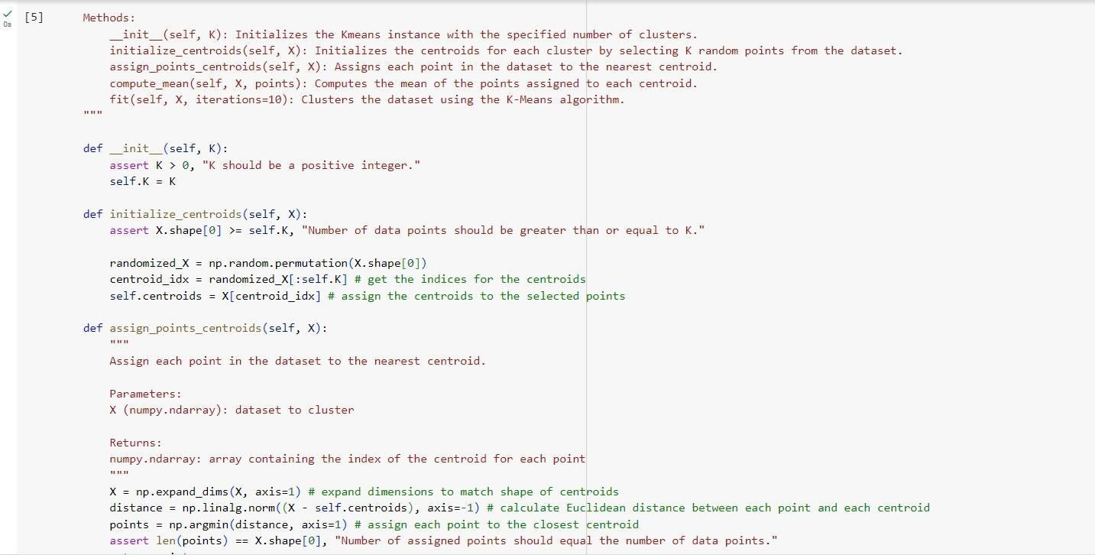

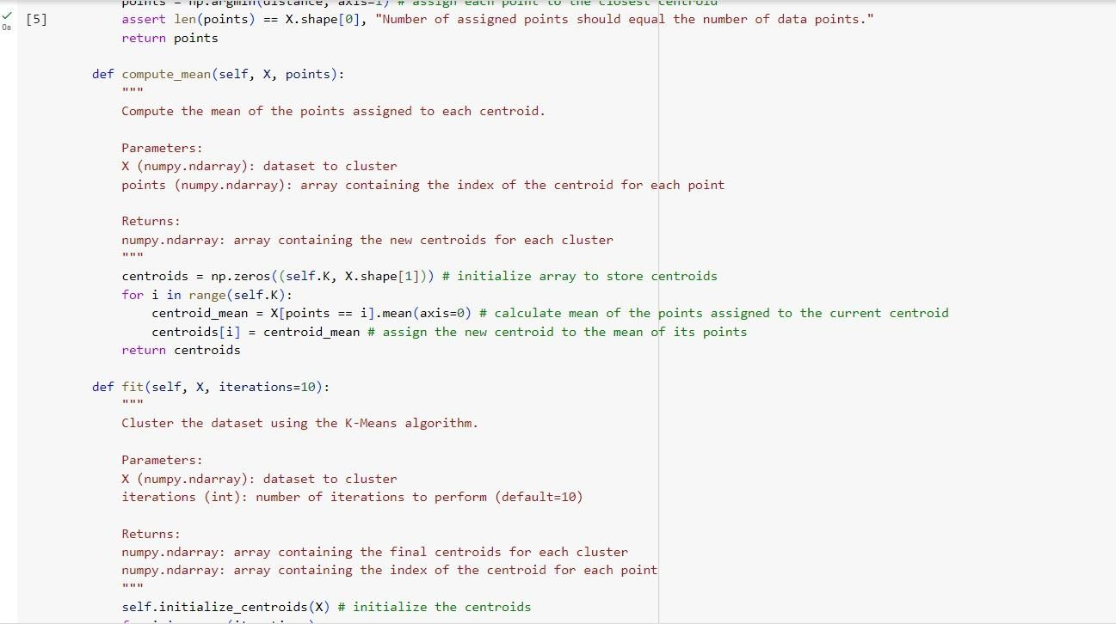

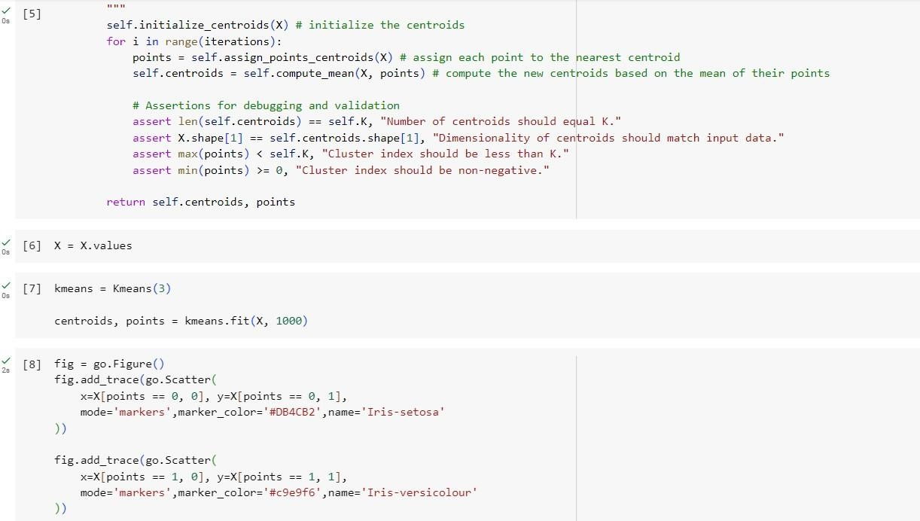

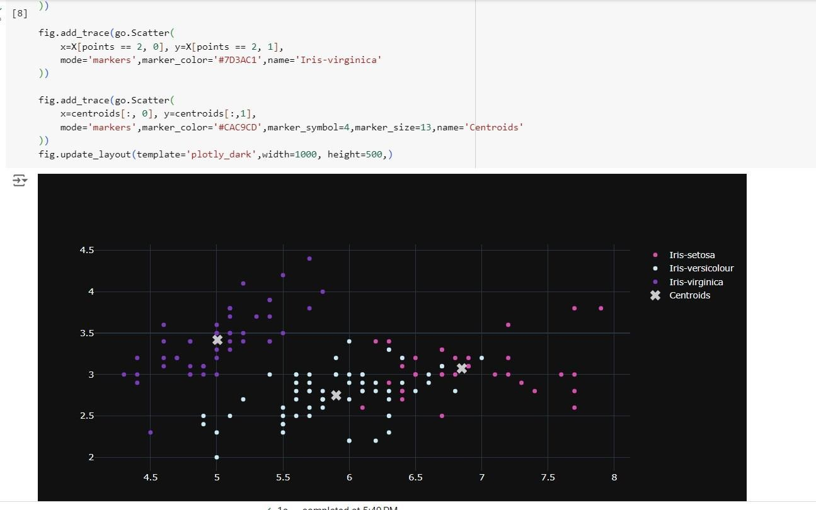

24/05/2024

Implement Dimensionality reduction using Principle Component Analysis (PCA) Algorithm:

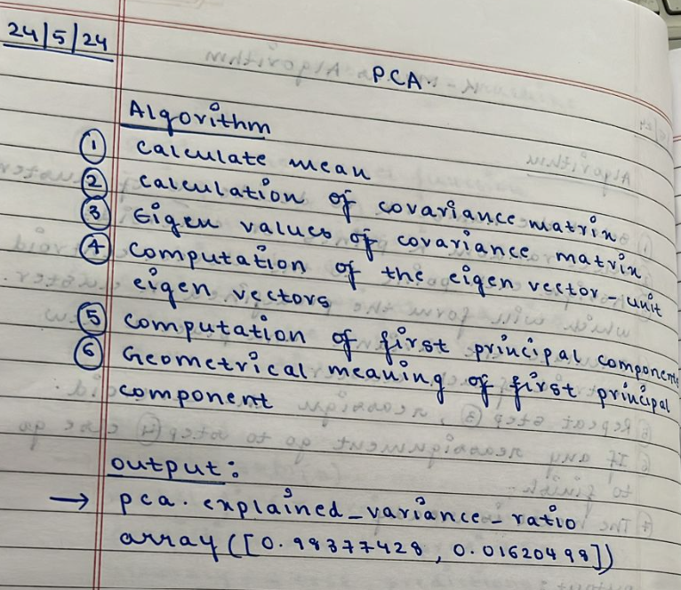

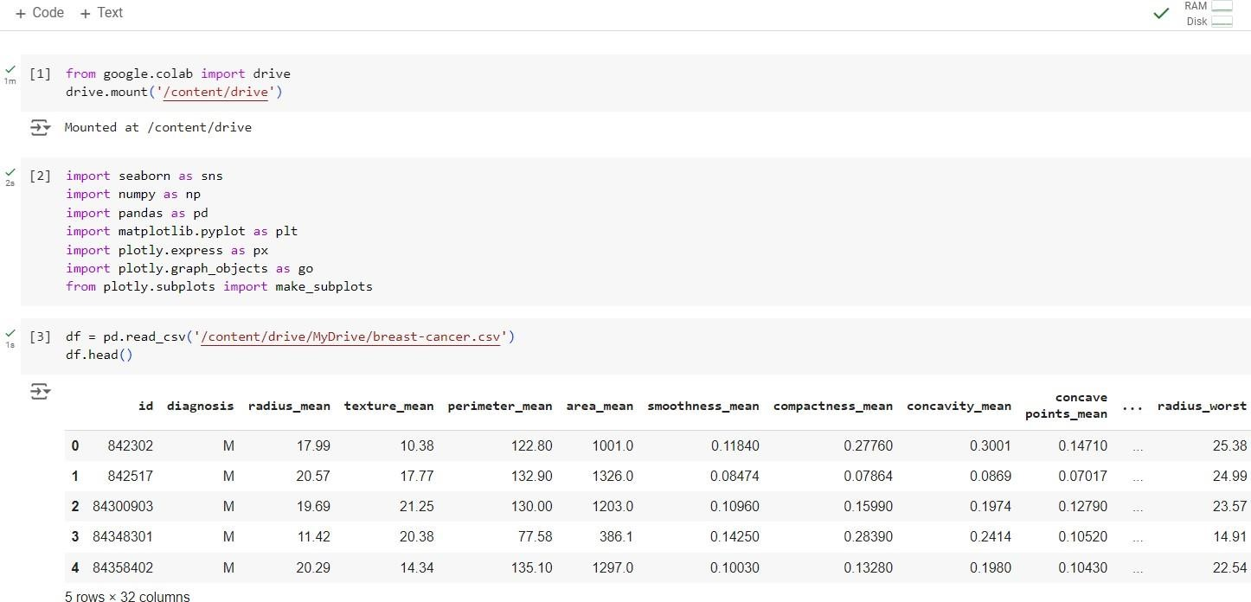

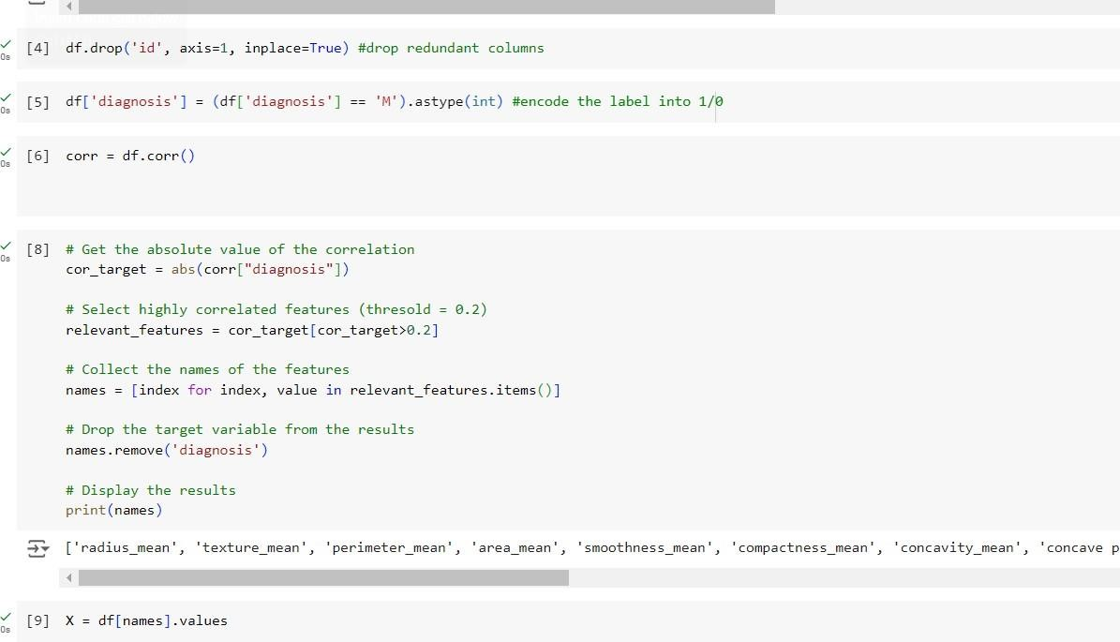

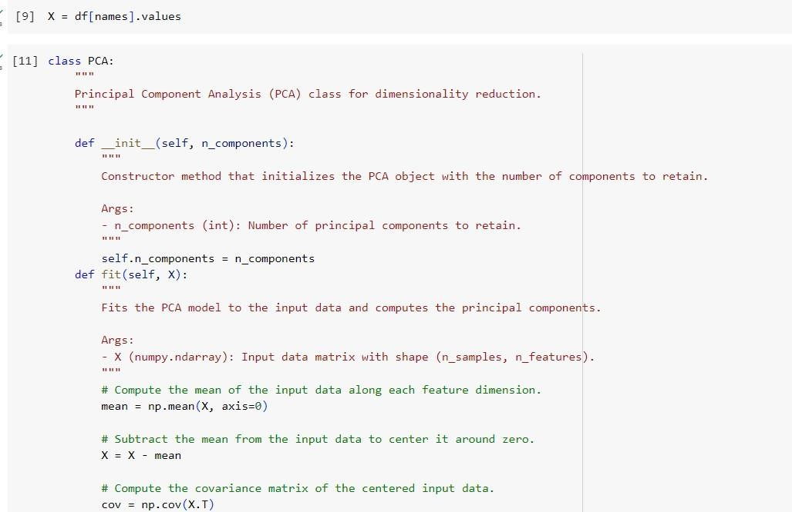

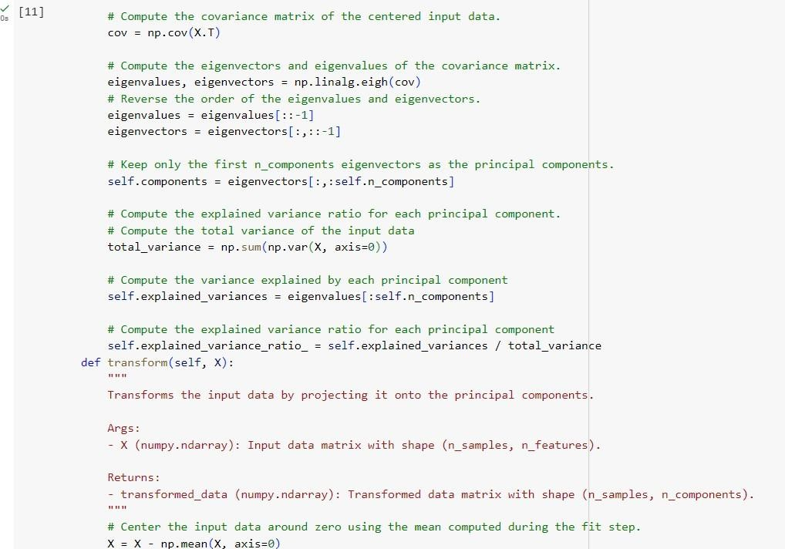

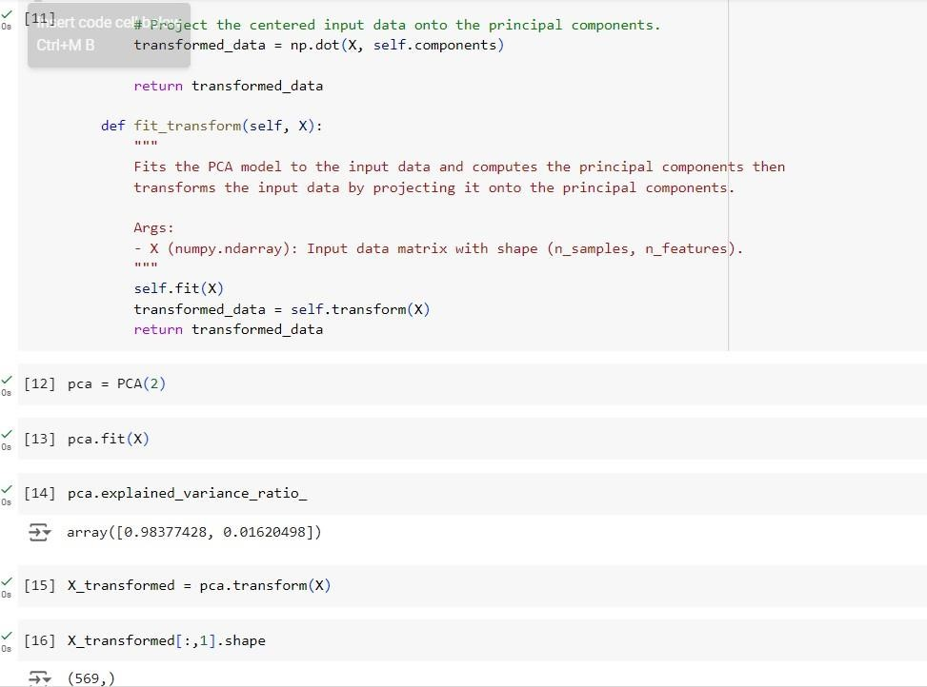

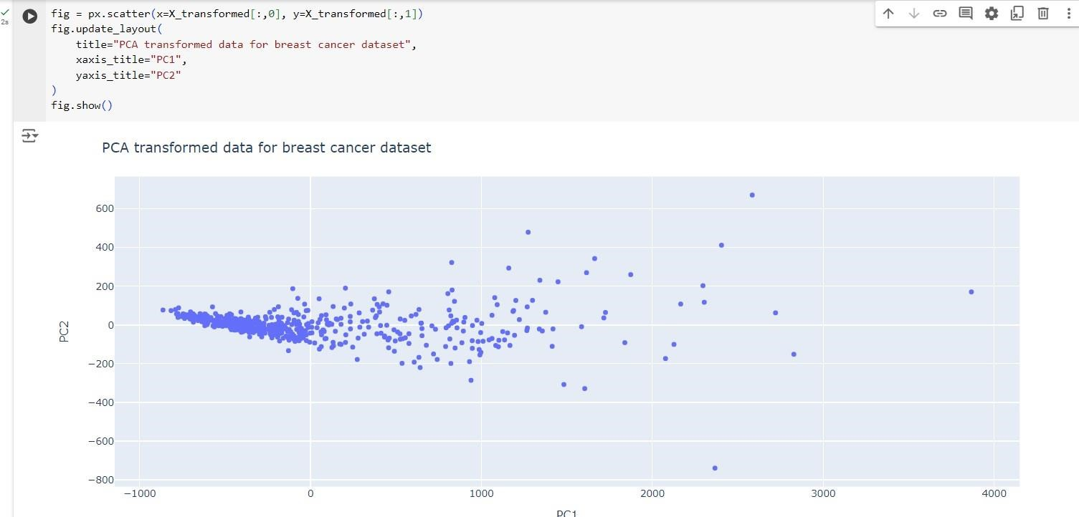

31.05.2024

Build Artificial Neural Network model with back propagation on a given dataset

Algorithm:

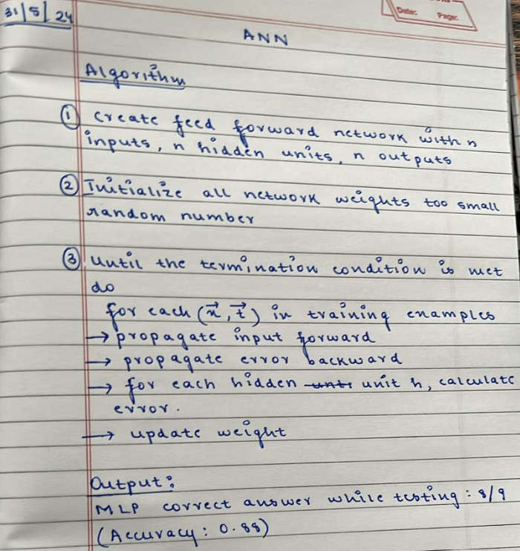

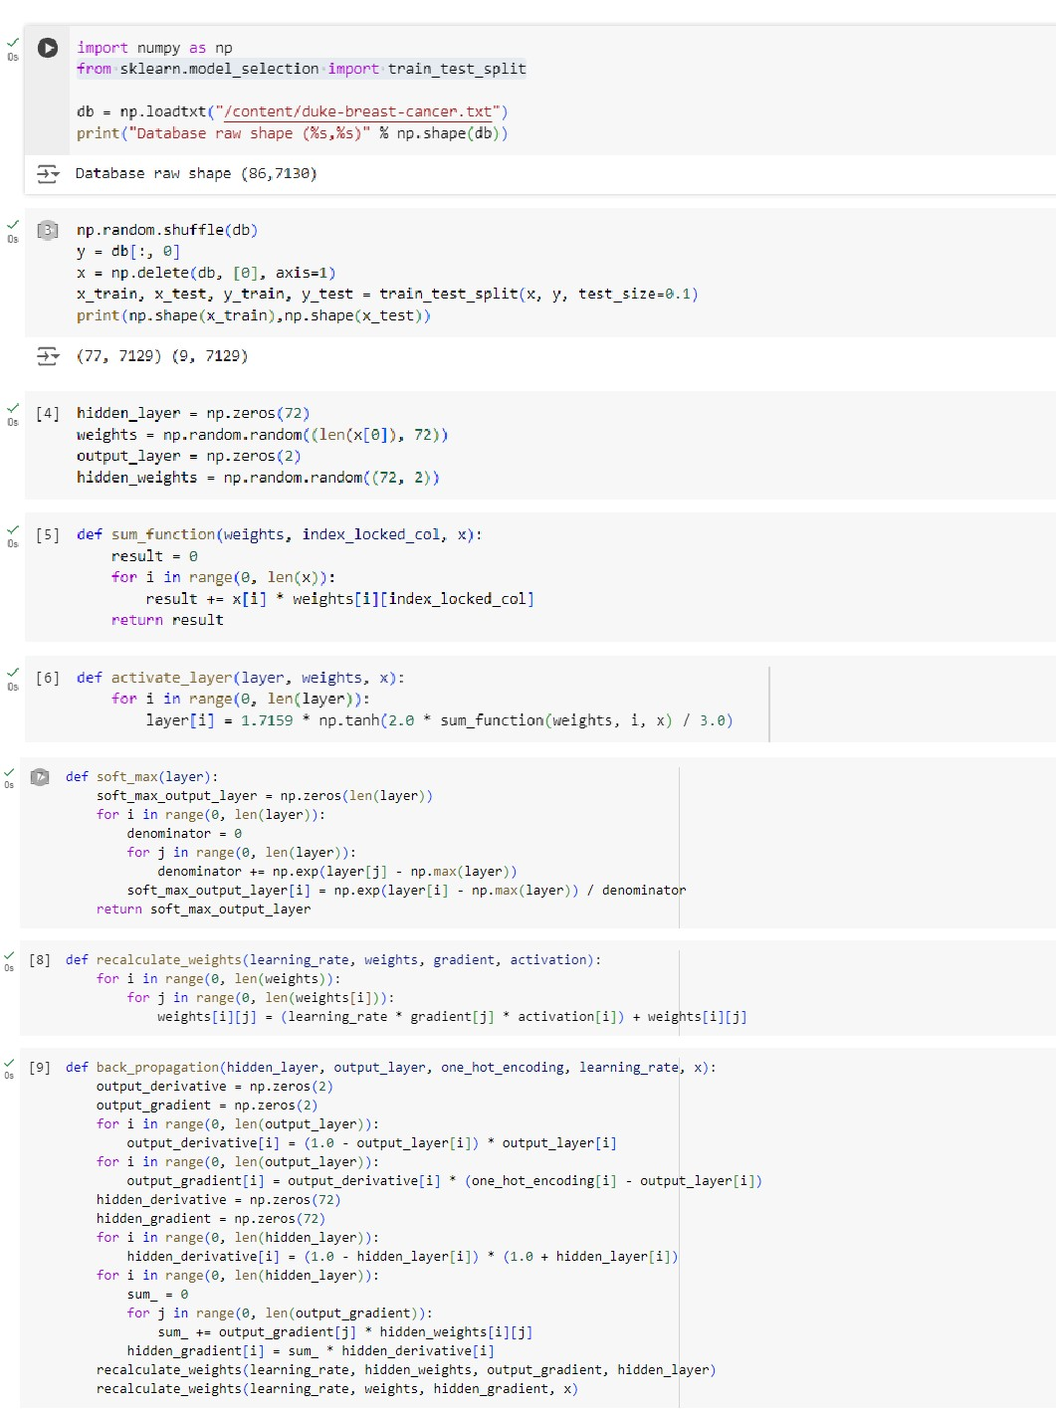

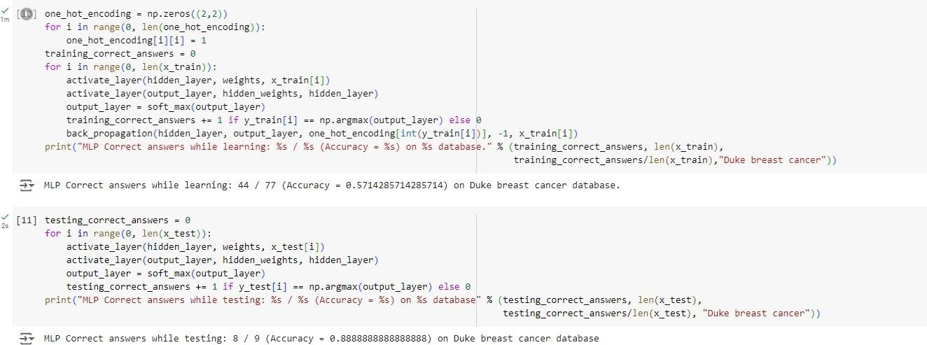

31.05.2024

Implement Random forest ensemble method on a given dataset.

Algorithm:

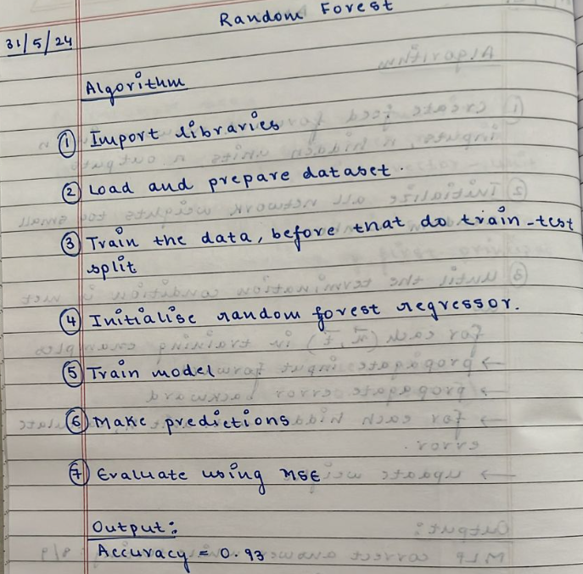

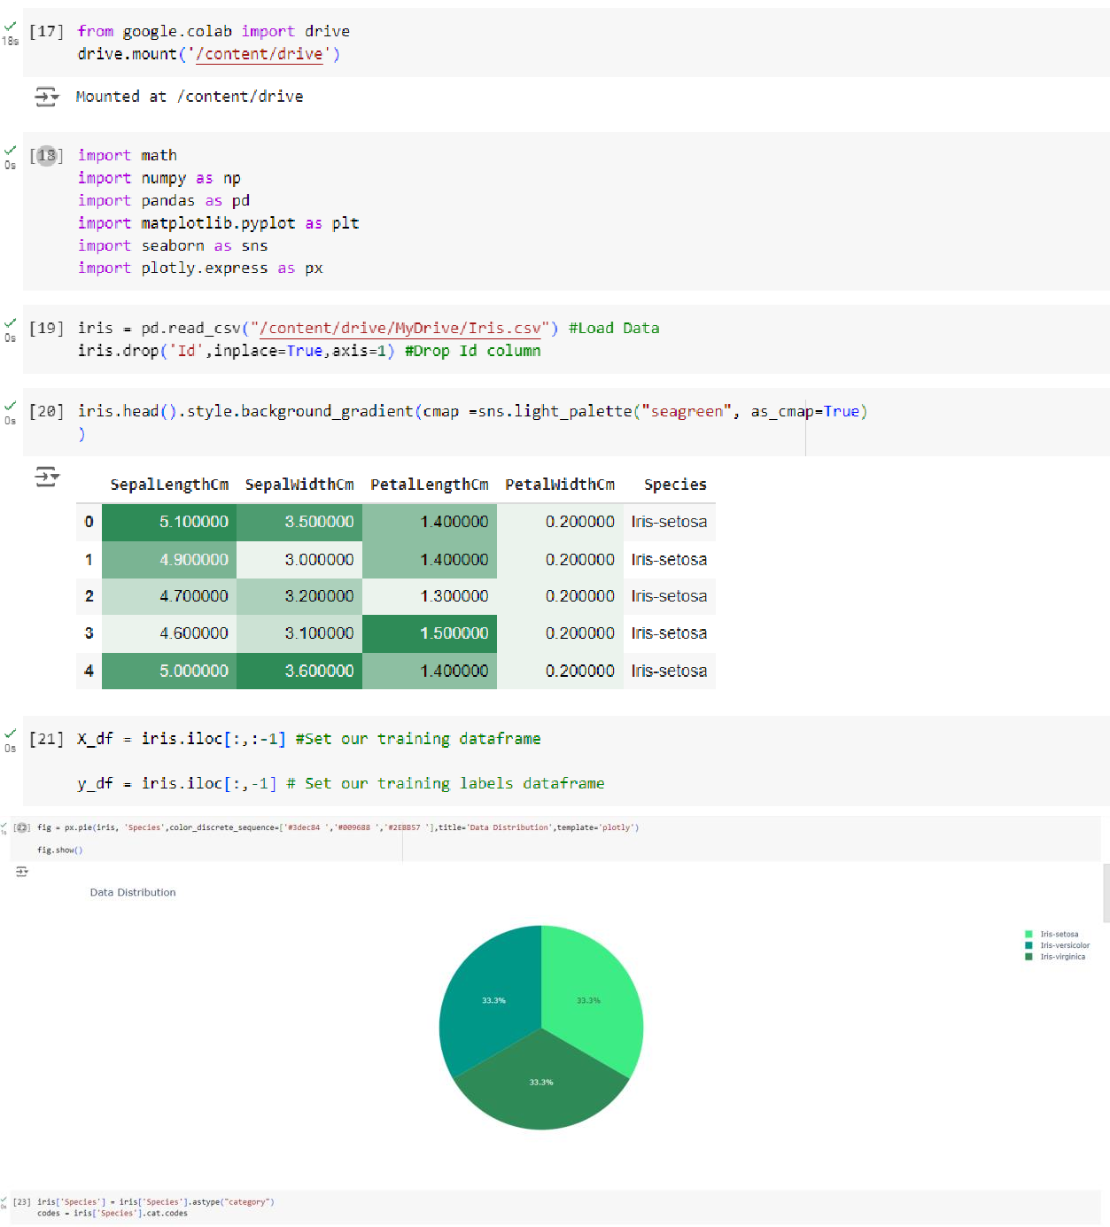

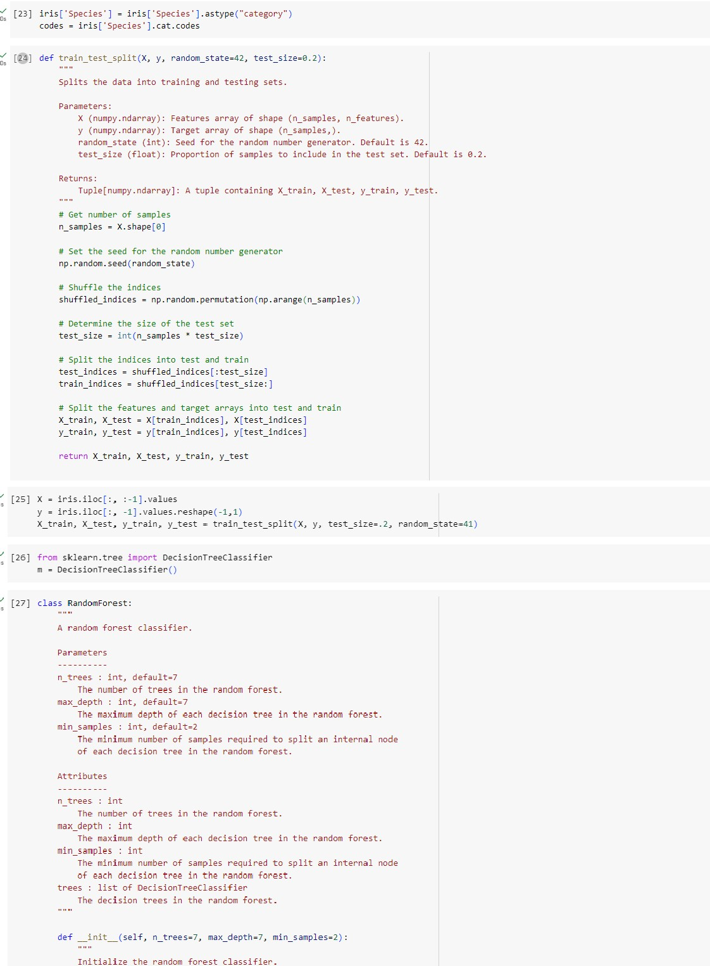

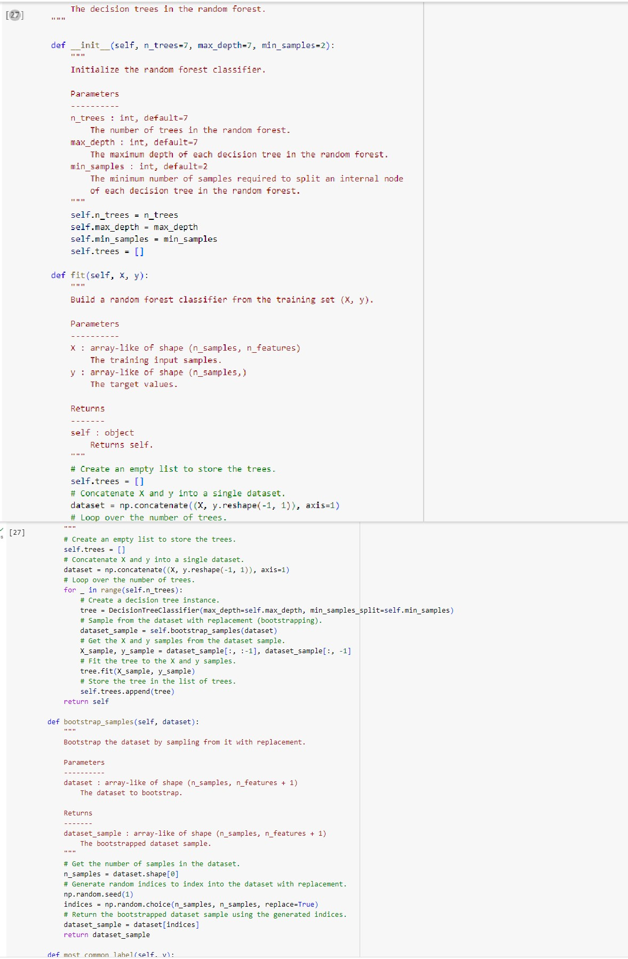

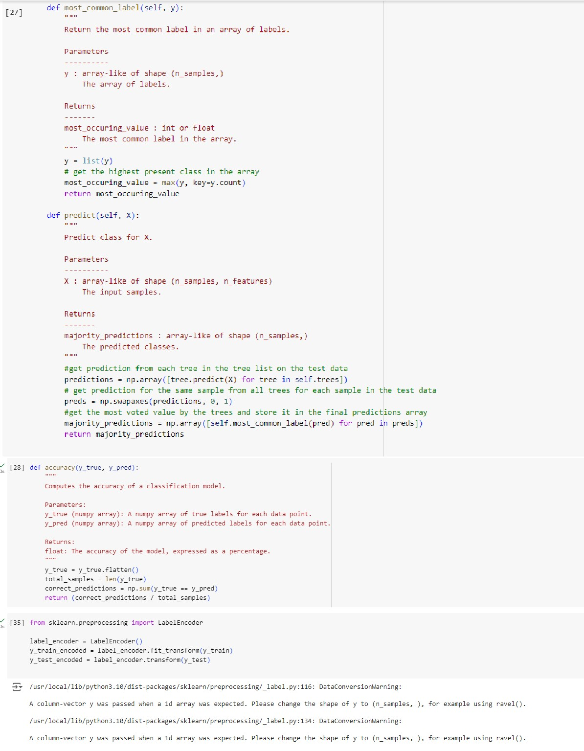

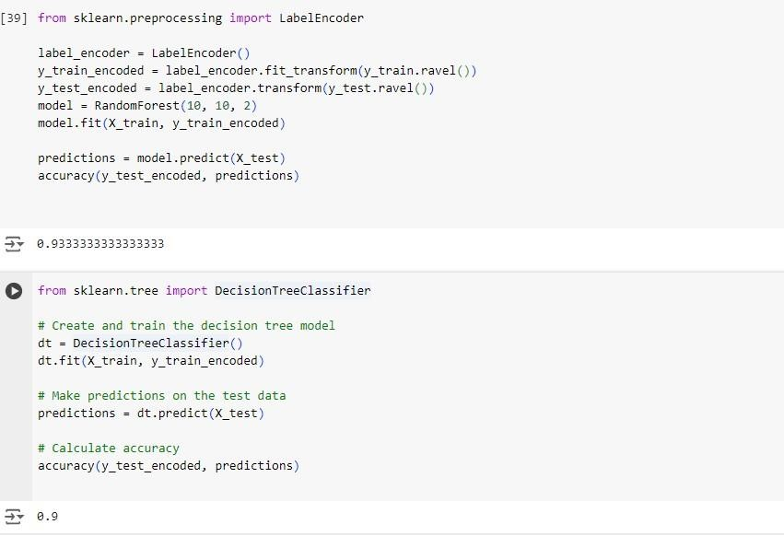

31.05.2024

Implement Boosting ensemble method on a given dataset.

Algorithm:

